Group One

Requirments Document

Group Members: Nika Pinder 812002915, Timothy Hinds 812003224, Dwane Alexis 812002736 , Leasean Celestine  812002983

User Requirements

Order Processing Module.

Standing Orders

1. The system is expected to allow the user to generate standing orders for a particular day.
2. The system is expected to allow the user to create new standing orders.
3. The system is expected to allow the user to view a standing order in full detail.
4. The system is expected to allow the user to make changes to standing orders.
5. The system is expected to allow the user to delete one standing order or more.
6. The system is expected to allow the user to delete all instances of an item in all standing orders.
7. The system is expected to allow the user to search for standing orders.
8. The system is expected to allow the user to search for an item using a description or item code.

Orders

1. The system is expected to allow the user to generate an order (s) from a standing order(s).
2. The system is expected to allow the user to view an order in full detail.
3. The system is expected to allow the user to edit an order.
4. The system is expected to allow the user to print one or more orders?
5. The system is expected to allow the user to delete one or more orders for a particular day.
6. The system is expected to allow the user to delete one or more orders for a particular customer
7. The system is expected to allow the user to search for orders using an order id date or customer information.

.

Invoices

1. The system is expected to allow the user to generate an invoice for each order.
2. The system is expected to allow the user to print one or more invoices.
3. The system is expected to allow the user to view an invoice in full detail.
4. The system is expected to allow the user to generate invoices for all orders made for a day.
5. The system is expected to allow the user to search for invoices.

Customer Web Application

1. The web app must provide a way for customers to log in
2. The web app must provide a way for customers to log out
3. The web app must provide a way for customers to view account details
4. The web app must provide a way for customers to view transaction history
5. The web app must provide a way for customers to view receivables
6. The web app must provide a way for customers to view statements
7. The web app must provide a way for customers to make a request to update the telephone/fax information
8. The web app must provide a way for customers to make a request to update their address information
9. The web app must provide a way for customers to make a request to update their customer name
10. The web app must provide a way for customers to search through their standing orders
11. The web app must provide a way for customers to make a request to modify standing order days
12. The web app must provide a way for customers to make a request to modify standing order items
13. The web app must provide a way for customers to make a request to modify standing order item quantities
14. The web app must provide a way for customers to make a request to modify standing order frequencies
15. The web app must provide a way for customers to make a request to delete standing orders
16. The web app must provide a way for customers to make a request to create standing order

User Requirements Delivery App

Invoices

1. The AkiProPlus system is expected to provide the means for a driver to have login credentials for the application.
2. The AkiProPlus system is expected to provide the means for a driver to see which invoices are on his route for that particular delivery day.
3. The AkiProPlus system is expected to provide the means for a driver to import those invoices from the system to the terminal.
4. The AkiProPlus system is expected to provide the means for a driver to print those invoices

Returns

1. The AkiProPlus system is expected to provide the means for a driver to view the deliveries made in the past to know which customers may have goods to return.
2. The AkiProPlus system is expected to provide the means for a driver to view those items that was delivered for a specific day selected.
3. The AkiProPlus system is expected to provide the means for a driver to import this information from the server to the terminal.
4. The AkiProPlus system is expected to provide the means for a driver to make data entries on goods return.
5. The AkiProPlus system is expected to provide the means for a driver to edit those changes made on return goods (in case an error was made).
6. The AkiProPlus system is expected to provide the means for a driver to save those changes on the terminal.
7. The AkiProPlus system is expected to provide the means for a driver to print return slips
8. The AkiProPlus system is expected to provide the means for a driver to synchronize all changes saved on the terminal to the main server.

Receivables

1. The AkiProPlus system is expected to provide the means for a driver to generate a credit note.
2. The AkiProPlus system is expected to provide the means for a driver to generate a debit note.

**Sales Rep App User Requirements**

1. User is expected to be able to view the Sales Analysis Report
2. User is expected to be able to view the Customer Item Sales Analysis Report
3. Provisions must be made for user to remove items for Customers’ Standing orders
4. Provisions must be made for user to view customer standing orders
5. Provisions must be made for user to adjust the amount of items on a Customers’ Standing Orders
6. User is expected to be able to add items to the list of items
7. User is expected to be able to remove items from the list of items

System Requirements

Non Functional

The system should be:

* Dependable
* Robust
* Interoperable
* Scalable
* Perform task quickly
* Secure

Functional Requirements

Customer Web Application

1. User requirement 1
   1. The web application must be able to accept username and password keyboard input
   2. The web application must be able to validate keyboard inputs against saved database entries
   3. The web application must be able to establish a connection with validated users
2. User requirement 2
   1. The web application must be able to terminate connections with logged in user
3. User requirement 3, 4, 5, 6
   1. The web application must be able to access user account database entries
   2. The web application must be able to display user account information
4. User requirement 7, 8, 9
   1. The web application must be able to provide users with the facilities to edit already populated fields
   2. The web application must be able to save requested changes in temporary storage
   3. The web application must be able to allow authorized employees to access the requested changes
   4. The web application must be able to allow authorized employees to approve and deny requested changes
5. User requirement 10
   1. The web application must be able to allow users to accept keyboard input in the search field
   2. The web application must be able to search through the standing order database based on keyboard input criteria
6. User requirement 11
   1. The web application must be able to allow the user to select the “Day” field for a standing order
   2. The web application must be able to allow the user to choose one of 7 days
7. User requirement 12
   1. The web application must be able to allow the user to select the “Items” field
   2. The web application must be able to allow the user to remove an item and accept keyboard input
   3. The web application must be able to search the item database based on the keyboard input criteria
   4. The web application must be able to save requested changes in temporary storage
   5. The web application must be able to allow authorized employees to access the requested changes
   6. The web application must be able to allow authorized employees to approve and deny requested changes
8. User requirements 13
   1. The web application must be able to allow the user to select the “Quantity” field
   2. The web application must be able to allow the user to accept keyboard input of numerical value
   3. The web application must be able to save requested changes in temporary storage
   4. The web application must be able to allow authorized employees to access the requested changes
   5. The web application must be able to allow authorized employees to approve and deny requested changes
9. User requirement 14
   1. The web application must be able to allow the user to select the “Frequency” field
   2. The web application must be able to allow the user to accept keyboard input of numerical value
   3. The web application must be able to save requested changes in temporary storage
   4. The web application must be able to allow authorized employees to access the requested changes
   5. The web application must be able to allow authorized employees to approve and deny requested changes
10. User requirement 15
    1. The web application must be able to allow the user to search for a standing order and delete
    2. The web application must be able to save requested changes in temporary storage
    3. The web application must be able to allow authorized employees to access the requested changes
    4. The web application must be able to allow authorized employees to approve and deny requested changes
11. User requirement 16
    1. The web application must be able to allow users to click the item field for a new order and accept keyboard input
    2. The web application must be able to search though database for items based on keyboard input
    3. The web application must be able to allow users to accept numerical values for quantity
    4. The web application must be able to allows users to select one of 7 days for “Day”
    5. The web application must be able to save requested changes in temporary storage
    6. The web application must be able to allow authorized employees to access the requested changes
    7. The web application must be able to allow authorized employees to approve and deny requested changes

Use Cases

|  |  |  |
| --- | --- | --- |
| **Use Case Number** | 1 | |
| **Use Case Name** | Log in using predetermined credentials | |
| **Related Requirements** | The customer must have and online account for which they can use to interface with the Aki Pro system | |
| **Goal In Context** | Successfully log in with the correct credentials | |
| **Pre-Condition** | The user must have a predetermined account | |
| **Successful End Condition** | The user logs in and is redirected to the account home page | |
| **Fail End Condition** | The user cannot log in and remains at the log in screen | |
| **Primary Actors** | Registered customers | |
| **Secondary Actors** | None | |
| **Trigger** | None | |
| **Main Flow** | **Step** | **Action** |
|  | 1 | User opens the Aki Pro web app |
|  | 2 | User clicks within the “Username” field and types their username |
|  | 3 | User clicks within the “Password” field and types their password |
|  | 4 | User presses enter or clicks log in button |
|  | 5 | User is redirected to homepage |

|  |  |  |
| --- | --- | --- |
| **Use Case Number** | 2 | |
| **Use Case Name** | Log Out | |
| **Related Requirements** | The customer must have and online account for which they can use to interface with the Aki Pro system | |
| **Goal In Context** | Successfully log out of an online session | |
| **Pre-Condition** | The user must be logged in | |
| **Successful End Condition** | The user can log out of a session | |
| **Fail End Condition** | The user cannot log out of a session | |
| **Primary Actors** | Registered customers | |
| **Secondary Actors** | None | |
| **Trigger** | None | |
| **Main Flow** | **Step** | **Action** |
|  | 1 | User goes to the navigation pane on top and selects “Log Out” |
|  | 2 | A confirmation window appears warning that unsaved changes will be lost. User clicks “Ok” |

|  |  |  |
| --- | --- | --- |
| **Use Case Number** | 3 | |
| **Use Case Name** | View Account Details (Refer to figure 1) | |
| **Related Requirements** | The customer must be able to view the details of their account | |
| **Goal In Context** | Successfully check the details of the account | |
| **Pre-Condition** | The user must have a predetermined account and must have done Use case #1 | |
| **Successful End Condition** | The user easily navigates to the account details page | |
| **Fail End Condition** | The user cannot view their account details | |
| **Primary Actors** | Registered customers | |
| **Secondary Actors** | None | |
| **Trigger** | None | |
| **Main Flow** | **Step** | **Action** |
|  | 1 | User browses through the home page and locates the “Account Details” link |
|  | 2 | User clicks the link and is redirected to the status page |

|  |  |  |
| --- | --- | --- |
| **Use Case Number** | 4 | |
| **Use Case Name** | View transaction History (Refer to figure 2) | |
| **Related Requirements** | The customer must be able to view transaction history | |
| **Goal In Context** | Successfully view transaction history | |
| **Pre-Condition** | The user must be logged in with predetermined account | |
| **Successful End Condition** | The user is able to look at their transaction history | |
| **Fail End Condition** | The user is unable to look at their transaction history | |
| **Primary Actors** | Registered customers | |
| **Secondary Actors** | None | |
| **Trigger** | None | |
| **Main Flow** | **Step** | **Action** |
|  | 1 | User goes to the navigation pane on top and selects “Account Details” |
|  | 2 | User goes to the “Transaction History” button and clicks it |

|  |  |  |
| --- | --- | --- |
| **Use Case Number** | 5 | |
| **Use Case Name** | View Receivables (Refer to figure 2) | |
| **Related Requirements** | The customer must be able to view their receivables | |
| **Goal In Context** | Successfully view transaction receivables | |
| **Pre-Condition** | The user must be logged in with predetermined account | |
| **Successful End Condition** | The user is able to look at their receivables | |
| **Fail End Condition** | The user cannot view their receivables | |
| **Primary Actors** | Registered customers | |
| **Secondary Actors** | None | |
| **Trigger** | None | |
| **Main Flow** | **Step** | **Action** |
|  | 1 | User goes to the navigation pane on top and selects “Account Details” |
|  | 2 | User goes to the “Receivables” button and clicks it |

|  |  |  |
| --- | --- | --- |
| **Use Case Number** | 6 | |
| **Use Case Name** | View Statements (Refer to figure 2) | |
| **Related Requirements** | The customer must be view their statements | |
| **Goal In Context** | Successfully view statements | |
| **Pre-Condition** | The user must be logged in with predetermined account | |
| **Successful End Condition** | The user is able to look at their statements | |
| **Fail End Condition** | The user cannot view their statements | |
| **Primary Actors** | Registered customers | |
| **Secondary Actors** | None | |
| **Trigger** | None | |
| **Main Flow** | **Step** | **Action** |
|  | 1 | User goes to the navigation pane on top and selects “Account Details” |
|  | 2 | User goes to the “Statements” button and clicks it |

|  |  |  |
| --- | --- | --- |
| **Use Case Number** | 7 | |
| **Use Case Name** | Change telephone/fax information (Refer to figure 2) | |
| **Related Requirements** | The web app must provide a way for customers to make a request to update their telephone/fax information | |
| **Goal In Context** | Successfully make a request to change telephone/fax | |
| **Pre-Condition** | The user must be logged in with predetermined account | |
| **Successful End Condition** | The user is able to make a request to change telephone/fax information | |
| **Fail End Condition** | The user cannot change their telephone/fax information | |
| **Primary Actors** | Registered customers | |
| **Secondary Actors** | Account Manager | |
| **Trigger** | Telephone/fax information is incorrect | |
| **Main Flow** | **Step** | **Action** |
|  | 1 | User goes to the navigation pane on top and selects “Account Details” |
|  | 2 | User clicks within the telephone/fax field and changes what is there |
|  | 3 | User saves changes |
|  |  |  |

|  |  |  |
| --- | --- | --- |
| **Use Case Number** | 8 | |
| **Use Case Name** | Change address information (Refer to figure 2) | |
| **Related Requirements** | The web app must provide a way for customers to make a request to update their address information | |
| **Goal In Context** | Successfully make a request to change address | |
| **Pre-Condition** | The user must be logged in with predetermined account | |
| **Successful End Condition** | The user is able to make a request to change address information | |
| **Fail End Condition** | The user cannot change their address information | |
| **Primary Actors** | Registered customers | |
| **Secondary Actors** | Account Manager | |
| **Trigger** | Address information is incorrect | |
| **Main Flow** | **Step** | **Action** |
|  | 1 | User goes to the navigation pane on top and selects “Account Details” |
|  | 2 | User clicks within the address field and changes what is there |
|  | 3 | User saves changes |

|  |  |  |
| --- | --- | --- |
| **Use Case Number** | 9 | |
| **Use Case Name** | Change customer name (Refer to figure 2) | |
| **Related Requirements** | The web app must provide a way for customers to make a request to update their name | |
| **Goal In Context** | Successfully make a request to change their name | |
| **Pre-Condition** | The user must be logged in with predetermined account | |
| **Successful End Condition** | The user is able to make a request to change customer name | |
| **Fail End Condition** | The user cannot change their name | |
| **Primary Actors** | Registered customers | |
| **Secondary Actors** | Account Manager | |
| **Trigger** | Customer Name is incorrect | |
| **Main Flow** | **Step** | **Action** |
|  | 1 | User goes to the navigation pane on top and selects “Account Details” |
|  | 2 | User clicks within the name field and changes what is there |
|  | 3 | User saves changes |

|  |  |  |
| --- | --- | --- |
| **Use Case Number** | 10 | |
| **Use Case Name** | Search for a standing order (Refer to figure 3) | |
| **Related Requirements** | The customer must be able to search for a standing order | |
| **Goal In Context** | Successfully find desired standing order | |
| **Pre-Condition** | The user must have a predetermined account and must have done Use case #1 and must have standing orders | |
| **Successful End Condition** | The user is able to find a standing order | |
| **Fail End Condition** | The user cannot find standing order | |
| **Primary Actors** | Registered customers | |
| **Secondary Actors** | None | |
| **Trigger** | None | |
| **Main Flow** | **Step** | **Action** |
|  | 1 | User goes to the navigation pane on top and selects “Standing Orders” |
|  | 2 | User goes to the right pane and selects “Search for Standing Order” |
|  | 3 | User types the necessary criteria |
|  | 4 | User clicks search |
|  | 5 | User selects one |

|  |  |  |
| --- | --- | --- |
| **Use Case Number** | 11 | |
| **Use Case Name** | Modify Standing Order Day (Refer to figure 4) | |
| **Related Requirements** | The customer must be able make requests to modify standing order days | |
| **Goal In Context** | Successfully make a standing order day modification request | |
| **Pre-Condition** | The user must have standing orders | |
| **Successful End Condition** | The user is able to make the necessary changes and send the request for approval | |
| **Fail End Condition** | The user cannot make changes to a standing order day | |
| **Primary Actors** | Registered customers | |
| **Secondary Actors** | Order Processing Employee | |
| **Trigger** | None | |
| **Main Flow** | **Step** | **Action** |
|  | 1 | User goes to the navigation pane on top and selects “Standing Orders” |
|  | 2 | User does Use case #3 |
|  | 3 | User goes to the right pane and selects “Modify Standing Order” |
|  | 4 | User clicks on the day field and changes the current day of the standing order |
|  | 5 | User clicks the “Save changes” button to the bottom |

|  |  |  |
| --- | --- | --- |
| **Use Case Number** | 12 | |
| **Use Case Name** | Modify Standing Order Item (Refer to figure 4) | |
| **Related Requirements** | The customer must be able make requests to modify standing order items | |
| **Goal In Context** | Successfully make a standing order item modification request | |
| **Pre-Condition** | The user must have standing orders | |
| **Successful End Condition** | The user is able to make the necessary changes and send the request for approval | |
| **Fail End Condition** | The user cannot make changes to a standing order’s items | |
| **Primary Actors** | Registered customers | |
| **Secondary Actors** | Order Processing Employee | |
| **Trigger** | None | |
| **Main Flow** | **Step** | **Action** |
|  | 1 | User goes to the navigation pane on top and selects “Standing Orders” |
|  | 2 | User does Use case #3 |
|  | 3 | User goes to the right pane and selects “Modify Standing Order” |
|  | 4 | User clicks on the “Search Item” field and types desired item name |
|  | 5 | User clicks Add Time |
|  | 6 | User clicks the “Save changes” button to the bottom |

|  |  |  |
| --- | --- | --- |
| **Use Case Number** | 13 | |
| **Use Case Name** | Modify Standing Order Item Quantity (Refer to figure 4) | |
| **Related Requirements** | The customer must be able make requests to modify standing order item quantities | |
| **Goal In Context** | Successfully make a standing order item quantity modification request | |
| **Pre-Condition** | The user must have standing orders | |
| **Successful End Condition** | The user is able to make the necessary changes and send the request for approval | |
| **Fail End Condition** | The user cannot make changes to a standing order item quantity | |
| **Primary Actors** | Registered customers | |
| **Secondary Actors** | Order Processing Employee | |
| **Trigger** | None | |
| **Main Flow** | **Step** | **Action** |
|  | 1 | User goes to the navigation pane on top and selects “Standing Orders” |
|  | 2 | User does use case #3 |
|  | 3 | User goes to the right pane and selects “Modify Standing Order” |
|  | 4 | User clicks on the quantity column for an item and changes the quantity |
|  | 5 | User clicks the “Save changes” button to the bottom |

|  |  |  |
| --- | --- | --- |
| **Use Case Number** | 14 | |
| **Use Case Name** | Modify Standing Order Frequency (Refer to figure 4) | |
| **Related Requirements** | The customer must be able make requests to modify standing order frequency | |
| **Goal In Context** | Successfully make a standing order item frequency modification request | |
| **Pre-Condition** | The user must have standing orders | |
| **Successful End Condition** | The user is able to make the necessary changes and send the request for approval | |
| **Fail End Condition** | The user cannot make changes to a standing order frequency | |
| **Primary Actors** | Registered customers | |
| **Secondary Actors** | Order Processing Employee | |
| **Trigger** | None | |
| **Main Flow** | **Step** | **Action** |
|  | 1 | User goes to the navigation pane on top and selects “Standing Orders” |
|  | 2 | User does use case #3 |
|  | 3 | User goes to the right pane and selects “Modify Standing Order” |
|  | 4 | User clicks on frequency and chooses a desired frequency |
|  | 5 | User clicks the “Save changes” button |

|  |  |  |
| --- | --- | --- |
| **Use Case Number** | 15 | |
| **Use Case Name** | Delete standing order (Refer to figure 3) | |
| **Related Requirements** | The web app must provide a way for customers to make a request to delete standing orders | |
| **Goal In Context** | Successfully make a request to delete a standing order | |
| **Pre-Condition** | The user must be logged in with predetermined account | |
| **Successful End Condition** | The user is able to make a request to delete a standing order | |
| **Fail End Condition** | The user cannot create make a request to delete a standing order | |
| **Primary Actors** | Registered customers | |
| **Secondary Actors** | Order Processing Employee | |
| **Trigger** | None | |
| **Main Flow** | **Step** | **Action** |
|  | 1 | User goes to the navigation pane on top and selects “Standing Orders” |
|  | 2 | User goes to right pane and selects “Delete Standing Order” |
|  | 3 | User does use case #3 |
|  | 4 | User goes to right pane and selects delete |
|  | 5 | Confirmation window comes up and user selects yes |
|  | 6 | User saves changes |

|  |  |  |
| --- | --- | --- |
| **Use Case Number** | 16 | |
| **Use Case Name** | Create standing order (Refer to figure 5) | |
| **Related Requirements** | The web app must provide a way for customers to make a request to create standing orders | |
| **Goal In Context** | Successfully make a request to add a new standing order | |
| **Pre-Condition** | The user must be logged in with a predetermined account | |
| **Successful End Condition** | The user is able to make a request to create and add a new standing order | |
| **Fail End Condition** | The user cannot create and add a new standing order | |
| **Primary Actors** | Registered customers | |
| **Secondary Actors** | Order Processing Employee | |
| **Trigger** | None | |
| **Main Flow** | **Step** | **Action** |
|  | 1 | User goes to the navigation pane on top and selects “Standing Orders” |
|  | 2 | User goes to right pane and selects “Create New Standing order” |
|  | 3 | User chooses a day |
|  | 4 | User chooses and item |
|  | 5 | User chooses a quantity |
|  | 6 | User chooses frequency |
|  | 7 | User saves changes |

**Sales Rep System requirements**

1. User Log in
   1. Application must allow User to log in with their username and password
   2. Application must validate user name and password against entries saved in database
2. User Log Off
   1. Application must allow the User with the option to log out
3. Navigation
   1. Application must allow the user with a method of navigation to go back to the previous screen
   2. Application must allow the user with a method of navigation to go back to the home screen
4. Home Screen Options
   1. Application must allow the user the option to go to item list
   2. Application must allow the user the option to go to standing orders
   3. Application must allow the user the option to go to reports
5. Item list Options
   1. Application must allow the user to view the item list
   2. Application must allow the user to add an item to the list
   3. Application must allow the user to remove an item from the list
6. Reports Options
   1. Application must allow the user to view Customer Sales Analysis Report
   2. Application must allow the user to view Item Sales Analysis Report
7. Standing Orders Options
   1. Application must allow the user to view customer standing orders
   2. Application must allow the user to edit customer standing orders
8. Adding item to list
   1. Application must accept input from user when adding an item to the list
9. Removing item from the list
   1. Application must allow the user to search for an item that is to be removed
   2. Application must accept user input when user wishes to search
10. Editing customer standing orders
    1. Application must allow the user to search for a customer standing order they wish the edit
    2. Application must accept user input when user wishes to search for customer standing order

**Sales Rep Application Use Cases**

|  |  |  |  |
| --- | --- | --- | --- |
| Use Case Number | | 1 | |
| Use Case Name | | Change Customer Standing Order | |
| Related Requirements | | Customer number, Standing Order number | |
| Goal in Context | | Change Customer Standing Order to a more suitable order | |
| Pre-Condition | | Customer must have existing standing order | |
| Successful End Condition | | User changed standing order successfully | |
| Fail End Condition | | User unable to change standing order | |
| Primary Actors | | Sales Representative | |
| Secondary Actors | |  | |
| Trigger | | Returns are over 10% | |
| Main Flow | Step | | Action |
|  | 1 | | User logs into application |
|  | 2 | | Selects Standing Orders Option |
|  | 3 | | Selects Edit Standing Order |
|  | 4 | | Searches for standing order to edit by entering information about standing order |
|  | 5 | | Selects standing order from list returned |
|  | 6 | | Makes changes to standing order |
|  | 7 | | Saves changes by selecting save |

|  |  |  |  |
| --- | --- | --- | --- |
| Use Case Number | | 2 | |
| Use Case Name | | Add item to list | |
| Related Requirements | | Item name, Item number | |
| Goal in Context | | To change out underselling products with selling products | |
| Pre-Condition | | Item must not already exist | |
| Successful End Condition | | User updates item list successfully | |
| Fail End Condition | | User unable to update item list | |
| Primary Actors | | Sales Representative | |
| Secondary Actors | |  | |
| Trigger | | There is a new item that is for sale | |
| Main Flow | Step | | Action |
|  | 1 | | User logs into application |
|  | 2 | | User selects Item list option |
|  | 3 | | User selects add item option |
|  | 4 | | User enters the item information |
|  | 5 | | User presses add item button |

|  |  |  |  |
| --- | --- | --- | --- |
| Use Case Number | | 3 | |
| Use Case Name | | Remove item from list | |
| Related Requirements | | Item number, Item name | |
| Goal in Context | | To remove an item from the item list | |
| Pre-Condition | | Item must already exist | |
| Successful End Condition | | Item was successfully removed | |
| Fail End Condition | | Item was not successfully removed | |
| Primary Actors | | Sales Rep | |
| Secondary Actors | |  | |
| Trigger | | Item Sales low | |
| Main Flow | Step | | Action |
|  |  | | User logs into application |
|  |  | | User selects item list |
|  |  | | User selects remove item |
|  |  | | User searches for item to be removed by entering the item information |
|  |  | | User selects the item from list returned |
|  |  | | User selects remove |

|  |  |  |  |
| --- | --- | --- | --- |
| Use Case Number | | 4 | |
| Use Case Name | | View Reports | |
| Related Requirements | | Report Name | |
| Goal in Context | | To view a report | |
| Pre-Condition | | Report must be up to date | |
| Successful End Condition | | Successful viewing of report | |
| Fail End Condition | | Unsuccessful viewing of report | |
| Primary Actors | | Sales Rep | |
| Secondary Actors | |  | |
| Trigger | |  | |
| Main Flow | Step | | Action |
|  | 1 | | User logs into application |
|  | 2 | | User selects reports |
|  | 3 | | User selects the report that is needed to be viewed |
|  | 4 | | User views report |

|  |  |  |  |
| --- | --- | --- | --- |
| Use Case Number | | 5 | |
| Use Case Name | | Log in | |
| Related Requirements | | Username, Password | |
| Goal in Context | | Log into application | |
| Pre-Condition | | Application installed on device | |
| Successful End Condition | | Successful log in | |
| Fail End Condition | | Unsuccessful log in | |
| Primary Actors | | Sales Representative | |
| Secondary Actors | |  | |
| Trigger | | Incorrect username or password | |
| Main Flow | Step | | Action |
|  | 1 | | Users opens application |
|  | 2 | | User Enters username and password |
|  | 3 | | User proceeds to log in |

|  |  |  |  |
| --- | --- | --- | --- |
| Use Case Number | | 6 | |
| Use Case Name | | Log out | |
| Related Requirements | |  | |
| Goal in Context | | Log out of application | |
| Pre-Condition | | Currently logged into application | |
| Successful End Condition | | Successful log out | |
| Fail End Condition | | Unsuccessful log out | |
| Primary Actors | | Sales Representative | |
| Secondary Actors | |  | |
| Trigger | |  | |
| Main Flow | Step | | Action |
|  | 1 | | User selects log out option |
|  | 2 | | User awaits successful log out |

Delivery Application System Requirements

System Requirements

1. The AkiProPlus system should function on an android OS.
2. The AkiProPlus system should provide a repository on the terminal to edit the changes made to imported information.
3. The AkiProPlus system should save all changes made by the user on the android device.
4. The AkiProPlus system should automatically generate the return slips for printing
5. The AkiProPlus system should back-up all updates made to the terminal.
6. The AkiProPlus system, driver’s application should connect to the main server, in order to import information to the tablet.
7. The AkiProPlus system, driver’s application should connect to the main server, in order to synchronize information from the tablet to the main server.
8. The AkiProPlus system, should only allow these synchronizations to commence once it has been approved by an authorized personnel.
9. The AkiProPlus system, should have a printing mechanism linked to the android device to output customer invoices.
10. The AkiProPlus system driver’s application should have access to historical delivery information (i.e. delivery made in the previous day or week)
11. The AkiProPlus system should validate a driver’s user credentials.
12. Once the AkiProPlus system validates a driver’s user credentials, the system should only allow the user to see information relevant to his credentials (i.e. they should only import the invoices on his delegated route).

Use Cases

|  |  |  |  |
| --- | --- | --- | --- |
| Use Case Number | | 1 | |
| Use Case Name | | Importing customer invoices | |
| Related Requirements | | Delivery Day | |
| Goal in Context | | To store customer invoices on tablet terminal | |
| Pre-Condition | | User Log in successfully | |
| Successful End Condition | | Information imported to terminal without errors | |
| Fail End Condition | | An error occurred while importing invoices | |
| Primary Actors | | Driver | |
| Secondary Actors | | Office Manager | |
| Trigger | | Invoices are required for drivers daily transactions | |
| Main Flow | Step | | Action |
|  | 1 | | User log in to the application |
|  | 2 | | Specify the delivery day in the “delivery day” combo box |
|  | 3 | | Click on the customer invoice button |
|  | 4 | | Select invoices to import with the checkboxes |
|  | 5 | | Click the import button |

|  |  |  |  |
| --- | --- | --- | --- |
| Use Case Number | | 2 | |
| Use Case Name | | Importing delivery history data | |
| Related Requirements | | Orders delivered for the week | |
| Goal in Context | | To determine who may have goods to return | |
| Pre-Condition | | User Log in successfully | |
| Successful End Condition | | Data imported successfully | |
| Fail End Condition | | An error occurred while importing the data | |
| Primary Actors | | Driver | |
| Secondary Actors | | Office Manager | |
| Trigger | |  | |
| Main Flow | Step | | Action |
|  | 1 | | User log in to the application |
|  | 2 | | Select a day in the past under “delivery history” |
|  | 3 | | Click on view history |
|  | 4 | | Select the items you would like to import |
|  | 5 | | Click on the import button |
|  |  | |  |
| Use Case Number | | 3 | |
| Use Case Name | | Returning goods | |
| Related Requirements | | Item name, Invoice ID | |
| Goal in Context | | Making changes to the system as they occur | |
| Pre-Condition | | User Login successfully | |
| Successful End Condition | | Information synched from terminal without errors | |
| Fail End Condition | | Information was unable to sync to the server | |
| Primary Actors | | Driver | |
| Secondary Actors | | Office Clerk | |
| Trigger | | The shelf life of goods have expired | |
| Main Flow | Step | | Action |
|  | 1 | | User log in to the application |
|  | 2 | | Import data on the delivery history for a particular day |
|  | 3 | | Once imported click on the edit button |
|  | 4 | | Enter the amount return and return date in the returns data entry form. |
|  | 5 | | Click on the view changes button. |
|  | 6 | | Once the data is accurate click save |
|  | 7 | | Then click on the print button for return slips |
|  | 8 | | The sync button is to be clicked only when you are on the office compound. |

|  |  |  |  |
| --- | --- | --- | --- |
| Use Case Number | | 4 | |
| Use Case Name | | Addressing discrepancies | |
| Related Requirements | | Invoice No., Credit Note No. and Debit Note No. | |
| Goal in Context | | Issuing debit and credit notes | |
| Pre-Condition | | User Log in successfully | |
| Successful End Condition | | No conflicts with updated customer information | |
| Fail End Condition | | Conflict arise with the issued notes numbers | |
| Primary Actors | | Driver | |
| Secondary Actors | | Office Clerk | |
| Trigger | | Discrepancy with orders | |
| Main Flow | Step | | Action |
|  | 1 | | User login to the application |
|  | 2 | | Once the invoices were imported click on the “details” button |
|  | 3 | | Click on the “generate credit note” or “generate debit note” button |

Order Processing System Requirements

1. The system should authenticate users with the user credentials and keep track of their activity using tokens

Standing Orders

1. The system to allow the user to generate standing orders for a particular day.
   1. The system should always carry the current date and time.

9.2 The system should accept date in the following format. Mm/dd/yy or Day of the week e.g Wednesday.

1. The system is expected to allow the user to create new standing orders.
   1. The system should ensure there is enough space to store new information.
2. The system is expected to allow the user to make changes to standing orders.
   1. The system should search for standing order in the database
   2. The system should commit changes to the database.
3. The system is expected to allow the user to delete one standing order or more.
   1. The system should allow the user to search for one or more standing orders.

12.2The system should access the standing orders from the database.

12.3The system should permanently remove standing orders from the database

1. The system is expected to allow the user to delete all instances of an item in all standing orders.
2. The system should allow the user to search for standing orders.
3. The system should allow the user to search for an item using a description or item code.

Orders

1. The system generate an order (s) from a standing order(s) before 11 am each day.

8.1 The system should save orders generated in the database

1. The system is expected to allow the user to view an order in full detail.

9.1 The system should allow the user to search for order by entering order id.

1. The system is expected to allow the user to edit an order.

10.1 The system should allow the user to search for order by entering order id.

* 1. The system should search for the order in the database.
  2. The system should generate some feedback if it is not found.

1. The system is expected to allow the user to print one or more orders
   1. The system should allow the user to search for one or more orders
   2. The system should access the orders from the database.
   3. The system should print the hardcopy of each order
2. The system is expected to allow the user to delete one or more orders.
   1. The system should allow the user to search for one or more orders.
   2. The system should access the orders from the database.
   3. The system should permanently remove orders from the database.
3. The system is expected to allow the user to delete one or more orders for a particular customer
   1. The system should allow the user to search for customer no.
   2. The system should allow the user to view all of the customer orders one screen.
4. The system is expected to allow the user to search for orders using an order id date or customer information.
   1. The system should accept an alphanumeric string from the user to specify the order.
   2. The system should allow the user to search for many orders by entering the day or customer no.

.

Invoices

1. The system should allow the user to generate an invoice for each order.
2. The system should allow the user to print one or more invoices.
3. The system should allow the user to view an invoice in full detail.
4. The system should allow the user to generate invoices for all orders made for a day.
5. The system should allow the user to search for invoices.

Order Processing Use Cases

|  |  |  |
| --- | --- | --- |
| **Use Case No:** | **1** | |
| **Requirement** | **To generate all standing orders for a particular day** | |
| **Related Requirement** | **The user must have the authority to view this information, standing orders must exist for that particular day.** | |
| **Goal In Context** | **This function allows the user to generate all standing orders needed for one day.** | |
| **Use Case Name** | **Generating Daily Standing Orders** | |
| **Pre-Conditions** | **The user must be logged onto the system.** | |
| **Successful End Condition** | **The user successfully generated all the standing orders for a day** | |
| **Failed End Condition** | **The user was unable to generate all the standing orders for a day** | |
| **Primary Actors** | **Office Clerk** | |
| **Secondary Actors** | **Manager** | |
| **Trigger** | **None** | |
| **Main Flow** | **Step** | **Action** |
|  | **1** | **The user successfully logs into the system and is presented with the home screen.** |
|  | **2** | **The user searches for standing orders Refer to Search use case how** |
|  | **3** | **The user selects the day the standing orders are to be generated.** |
|  | **4** | **The user selects the generate standing orders button and the ok button when the dialogue box appears to confirm the users action.** |

|  |  |  |
| --- | --- | --- |
| **Use Case No:** | **2** | |
| **Requirement** | **To edit a standing order** | |
| **Related Requirement** | **The user must find the standing order** | |
| **Goal In Context** | **This function allows the user to edit a standing order.** | |
| **Use Case Name** | **Edit Standing Orders** | |
| **Pre-Conditions** | **The user can must be logged onto the system** | |
| **Successful End Condition** | **The user successfully generated edit a standing order** | |
| **Failed End Condition** | **The user was unable to generate edit a standing order** | |
| **Primary Actors** | **Office Clerk** | |
| **Secondary Actors** | **Manager** | |
| **Trigger** | **The existing standing order incorrect or needed to be altered** | |
| **Main Flow** | **Step** | **Action** |
| **Service** |  | |  |  |  | | --- | --- | --- | | **Location** |  |  | |  |  |  | |
|  | **1** | **The user successfully logs into the system and is presented with the home screen.** |
|  | **2** | **Search for standing order. Refer to Search Use Case to see how.** |
|  | **3** | **Select the edit option from the menu.** |
|  | **4** | **Select the field or fields they wish to change.** |
|  | **5** | **Save changes by selecting the save button, upon which a dialogue box appears asking the user to confirm action. The user selects the ok button and the changes are saved.** |

|  |  |  |
| --- | --- | --- |
| **Use Case No:** | **3** | |
| **Requirement** | **To view Standing Order information** | |
| **Related Requirement** | **The user must find that standing order in the system** | |
| **Goal In Context** | **This function allows the user to view standing order.** | |
| **Use Case Name** | **View Standing Order.** | |
| **Pre-Conditions** | **The user can must be logged onto the system.** | |
| **Successful End Condition** | **The user successfully view a standing order.** | |
| **Failed End Condition** | **The user was unable to view a standing order.** | |
| **Primary Actors** | **Office Clerk** | |
| **Secondary Actors** | **Manager** | |
| **Trigger** | **None** | |
| **Main Flow** | **Step** | **Action** |
|  | **1** | **The user successfully logs into the system and is presented with the home screen.** |
|  | **2** | **Search for standing order. Refer to Search Use Case to see how this is done.** |
|  | **3** | **The user then selects (double clicks on) the standing order to view in full detail.** |

|  |  |  |
| --- | --- | --- |
| **Use Case No:** | **4** | |
| **Requirement** | **To Search for Standing Order(s)** | |
| **Related Requirement** | **Standing Order and Customers must exist in the system.** | |
| **Goal In Context** | **This function allows the user to search for standing order(s).** | |
| **Use Case Name** | **Search for Standing Order(s).** | |
| **Pre-Conditions** | **The user can must be logged onto the system.** | |
| **Successful End Condition** | **The user successfully finds the standing order(s).** | |
| **Failed End Condition** | **The user was unable to find standing order(s).** | |
| **Primary Actors** | **Office Clerk** | |
| **Secondary Actors** | **Manager** | |
| **Trigger** | **None** | |
| **Main Flow** | **Step** | **Action** |
|  | **1** | **The user successfully logs into the system and is presented with the home screen.** |
|  | **2** | **Select the drop down menu bar. Where the user is presented with the search option.** |
|  | **3** | **The user then selects the search option.** |
|  | **4** | **The search window appears prompting the user to enter standing order id, custno or day the user enters the custno or day.** |
|  | **5** | **The standing order(s) are generated.** |

|  |  |  |
| --- | --- | --- |
| **Use Case No:** | **5** | |
| **Requirement** | **Create a Standing Order** | |
| **Related Requirement** | **The user must be able to find the customer in the system to which the standing order belongs.** | |
| **Goal In Context** | **This function allows the user to create a standing order.** | |
| **Use Case Name** | **Create a Standing Order** | |
| **Pre-Conditions** | **The user can must be logged onto the system** | |
| **Successful End Condition** | **The user successfully create a standing order** | |
| **Failed End Condition** | **The user was unable to create a standing order** | |
| **Primary Actors** | **Office Clerk** | |
| **Secondary Actors** | **Manager** | |
| **Trigger** | **None** | |
| **Main Flow** | **Step** | **Action** |
| **Service test** | **Put** | |  |  | | --- | --- | | **Location** | **Test data** | | **64.28.139.185/akipro/orders.dll/datasnap/rest/TOrderProcess/standingorder/100017/198990** |  | |
|  | **1** | **The user successfully logs into the system and is presented with the home screen.** |
|  | **2** | **Searches for customer Refer to Search Use Case to see how.** |
|  | **3** | **Select from menu the new standing order option.** |
|  | **4** | **Selects the save button to create a standing order.** |

|  |  |  |
| --- | --- | --- |
| **Use Case No:** | **6** | |
| **Requirement** | **To log into the Aki Pro Application** | |
| **Related Requirement** | **The user must have access to company server** | |
| **Goal In Context** | **This function allows the user to log into the system.** | |
| **Use Case Name** | **Log onto Aki Pro Application** | |
| **Pre-Conditions** | **The user credentials must be validated and verify that they are authorized to view this information.** | |
| **Successful End Condition** | **The user login was successful.** | |
| **Failed End Condition** | **The user login was unsuccessful.** | |
| **Primary Actors** | **Office Clerk, Manager** | |
| **Secondary Actors** | **Technical Administrator** | |
| **Trigger** | **None** | |
| **Main Flow** | **Step** | **Action** |
|  | **1** | **The user opens the Aki Pro Application.** |
|  | **2** | **The user is presented with the login screen.** |
|  | **3** | **The user enters login credentials and selects the enter button to access the home screen.** |

|  |  |  |
| --- | --- | --- |
| **Use Case No:** | **1** | |
| **Requirement** | **To generate Order from Standing Order** | |
| **Related Requirement** | **The user must obtain the pre-exiting standing order** | |
| **Goal In Context** | **This function allows the user to generate an order from standing order.** | |
| **Use Case Name** | **Generates Order from Standing Order.** | |
| **Pre-Conditions** | **The user can must be logged onto the system.** | |
| **Successful End Condition** | **The user successfully generated an order from a standing order.** | |
| **Failed End Condition** | **The user was unable to generate an order from a standing order.** | |
| **Primary Actors** | **Office Clerk** | |
| **Secondary Actors** | **Manager** | |
| **Trigger** | **None** | |
| **Main Flow** | **Step** | **Action** |
|  | **1** | **The user successfully logs into the system and is presented with the home screen.** |
|  | **2** | **Search for standing order. Refer to Search Order Use Case to see how this is done.** |
|  | **3** | **Selects a day to generate the order.** |
|  | **4** | **Select the generate order button and a dialogue box appears informing the user of the outcome of proceeding with this action. The user has the option select ok or cancel.** |
|  | **5** | **Selects the ok button and the order are generated.** |

|  |  |  |
| --- | --- | --- |
| **Use Case No:** | **7** | |
| **Requirement** | **Delete Standing Order.** | |
| **Related Requirement** | **The user must find the standing orders in the system** | |
| **Goal In Context** | **This function allows the user to delete standing orders.** | |
| **Use Case Name** | **Delete Standing Orders** | |
| **Pre-Conditions** | **The user can must be logged onto the system** | |
| **Successful End Condition** | **The user successfully delete standing orders** | |
| **Failed End Condition** | **The user was unable delete standing orders** | |
| **Primary Actors** | **Office Clerk** | |
| **Secondary Actors** | **Manager** | |
| **Trigger** | **Current Standing Orders are invalid** | |
| **Main Flow** | **Step** | **Action** |
|  | **1** | **The user successfully logs into the system and is presented with the home screen.** |
|  | **2** | **Searches for standing order id. (Refer to Search Use Case to see how) and** |
|  | **3** | **Select from menu the delete option.** |
|  | **4** | **Selects the ok button to delete a standing order.** |

|  |  |  |
| --- | --- | --- |
| **Use Case No:** | **3** | |
| **Requirement** | **To generate all orders for a particular day** | |
| **Related Requirement** | **The orders must exist for that particular day.** | |
| **Goal In Context** | **This function allows the user to generate all orders needed for one day.** | |
| **Use Case Name** | **Generating Daily Orders** | |
| **Pre-Conditions** | **The user must be logged onto the system.** | |
| **Successful End Condition** | **The user successfully generated all orders for a day** | |
| **Failed End Condition** | **The user was unable to generate all the orders for a day** | |
| **Primary Actors** | **Office Clerk** | |
| **Secondary Actors** | **Manager** | |
| **Trigger** | **None** | |
| **Main Flow** | **Step** | **Action** |
|  | **1** | **The user successfully logs into the system and is presented with the home screen.** |
|  | **2** | **The user searches for orders Refer to Search Order use case** |
|  | **3** | **The user selects the day the orders are to be generated** |
|  | **4** | **The user selects the generate orders button and the ok button when the dialogue box appears to confirm the users action.** |

|  |  |  |
| --- | --- | --- |
| **Use Case No:** | **4** | |
| **Requirement** | **To edit an order** | |
| **Related Requirement** | **The user must find the order.** | |
| **Goal In Context** | **This function allows the user to edit an order.** | |
| **Use Case Name** | **Edit Order** | |
| **Pre-Conditions** | **The user can must be logged onto the system** | |
| **Successful End Condition** | **The user successfully generated edit an order** | |
| **Failed End Condition** | **The user was unable to generate edit an order** | |
| **Primary Actors** | **Office Clerk** | |
| **Secondary Actors** | **Manager** | |
| **Trigger** | **The existing standing order incorrect or needed to be altered** | |
| **Main Flow** | **Step** | **Action** |
|  | **1** | **The user successfully logs into the system and is presented with the home screen.** |
|  | **2** | **Search for order. Refer to Search Order Use Case to see how.** |
|  | **3** | **Select the edit option from the menu.** |
|  | **4** | **Select the field or fields they wish to change.** |
|  | **5** | **Save changes by selecting the save button, upon which a dialogue box appears asking the user to confirm action. The user selects the ok button and the changes are saved.** |

|  |  |  |
| --- | --- | --- |
| **Use Case No:** | **8** | |
| **Requirement** | **Delete all instances of an Item in Standing Orders** | |
| **Related Requirement** | **The user must be able to find the standing orders in the system.** | |
| **Goal In Context** | **This function allows the user to delete standing orders.** | |
| **Use Case Name** | **Delete Item from Standing Orders** | |
| **Pre-Conditions** | **The user can must be logged onto the system** | |
| **Successful End Condition** | **The user successfully deletes the item from all standing orders** | |
| **Failed End Condition** | **The user was unable deletes an item from all standing orders** | |
| **Primary Actors** | **Office Clerk** | |
| **Secondary Actors** | **Manager** | |
| **Trigger** | **None** | |
| **Main Flow** | **Step** | **Action** |
|  | **1** | **The user successfully logs into the system and is presented with the home screen.** |
|  | **3** | **Select the remove item option from the menu.** |
|  | **4** | **The user enters the item code and selects the ok button to delete all instance of that item from all standing orders.** |

|  |  |  |
| --- | --- | --- |
| **Use Case No:** | **2** | |
| **Requirement** | **To generate Orders from Standing Orders** | |
| **Related Requirement** | **There must find standing orders** | |
| **Goal In Context** | **This function allows the user to generate orders from standing orders** | |
| **Use Case Name** | **Generate Orders from Standing Orders** | |
| **Pre-Conditions** | **The user can must be logged onto the system** | |
| **Successful End Condition** | **The user successfully generated orders from standing orders** | |
| **Failed End Condition** | **The user was unable to generate orders from standing orders** | |
| **Primary Actors** | **Office Clerk** | |
| **Secondary Actors** | **Manager** | |
| **Trigger** | **None** | |
| **Main Flow** | **Step** | **Action** |
|  | **1** | **The user successfully logs into the system and is presented with the home screen.** |
|  | **2** | **Search for standing orders. Refer to Search Order Use Case to see how this is done.** |
|  | **3** | **Select the order day to generate the orders.** |
|  | **4** | **Select the generate order button and a dialogue box appears informing the user of the outcome of the action. The user selects the ok button and orders are generated.** |

|  |  |  |
| --- | --- | --- |
| **Use Case No:** | **9** | |
| **Requirement** | **To view Order information** | |
| **Related Requirement** | **The user must find that order in the system** | |
| **Goal In Context** | **This function allows the user to view order in full detail.** | |
| **Use Case Name** | **View Order.** | |
| **Pre-Conditions** | **The user can must be logged onto the system.** | |
| **Successful End Condition** | **The user successfully views an order.** | |
| **Failed End Condition** | **The user was unable to view an order.** | |
| **Primary Actors** | **Office Clerk** | |
| **Secondary Actors** | **Manager** | |
| **Trigger** | **None** | |
| **Main Flow** | **Step** | **Action** |
|  | **1** | **The user successfully logs into the system and is presented with the home screen.** |
|  | **3** | **Select the order option from the menu.** |
|  | **2** | **Search for an order. Refer to Search Order Use Case to see how this is done.** |
|  | **3** | **The user then selects (double clicks on) the standing order to view in full detail.** |

|  |  |  |
| --- | --- | --- |
| **Use Case No:** | **5** | |
| **Requirement** | **To cancel an order** | |
| **Related Requirement** | **The user must find the order.** | |
| **Goal In Context** | **This function allows the user to cancel an order.** | |
| **Use Case Name** | **Cancel an Order** | |
| **Pre-Conditions** | **The user can must be logged onto the system** | |
| **Successful End Condition** | **The user successfully cancelled an order** | |
| **Failed End Condition** | **The user was unable to cancel order** | |
| **Primary Actors** | **Office Clerk** | |
| **Secondary Actors** | **Manager** | |
| **Trigger** | **The existing order incorrect or is no longer needed.** | |
| **Main Flow** | **Step** | **Action** |
|  | **1** | **The user successfully logs into the system and is presented with the home screen.** |
|  | **2** | **Select the orders option from the menu.** |
|  | **3** | **Selects the cancel option** |
|  | **4** | **Search for the order. Refer to Search Order Use Case to see how.** |
|  | **5** | **Select the cancel button and a dialogue box appears asking the user to confirm action. The user selects the ok button and the order is cancelled.** |

|  |  |  |
| --- | --- | --- |
| **Use Case No:** | **6** | |
| **Requirement** | **To cancel orders for a particular day** | |
| **Related Requirement** | **The user must generate orders for a particular day.** | |
| **Goal In Context** | **This function allows the user to cancel all orders for a particular day** | |
| **Use Case Name** | **Cancel Orders** | |
| **Pre-Conditions** | **The user can must be logged onto the system** | |
| **Successful End Condition** | **The user successfully cancelled orders** | |
| **Failed End Condition** | **The user was unable to cancel orders** | |
| **Primary Actors** | **Office Clerk** | |
| **Secondary Actors** | **Manager** | |
| **Trigger** | **The user would have generated the incorrect orders for a particular day.** | |
| **Main Flow** | **Step** | **Action** |
|  | **1** | **The user successfully logs into the system and is presented with the home screen.** |
|  | **2** | **Select the orders option from the menu.** |
|  | **3** | **The user generates the orders for that particular day. Refer to Orders Use case.** |
|  | **4** | **Selects the cancel option.** |
|  | **5** | **Select the cancel button and a dialogue box appears asking the user to confirm action. The user selects the ok button and the orders are cancelled.** |

|  |  |  |
| --- | --- | --- |
| **Use Case No:** | **7** | |
| **Requirement** | **To print an order.** | |
| **Related Requirement** | **The user must find that order.** | |
| **Goal In Context** | **This function allows the user to print an order** | |
| **Use Case Name** | **Print Order** | |
| **Pre-Conditions** | **The user can must be logged onto the system** | |
| **Successful End Condition** | **The user successfully prints order** | |
| **Failed End Condition** | **The user was unable to print order** | |
| **Primary Actors** | **Office Clerk** | |
| **Secondary Actors** | **Manager** | |
| **Trigger** | **None** | |
| **Main Flow** | **Step** | **Action** |
|  | **1** | **The user successfully logs into the system and is presented with the home screen.** |
|  | **2** | **Select the orders option from the menu.** |
|  | **3** | **Searches for an order. Refer to Search Order Use case** |
|  | **4** | **Selects the print option.** |
|  | **5** | **A dialogue box appears asking the user to confirm action. The user selects the ok button and the order is printed.** |

|  |  |  |
| --- | --- | --- |
| **Use Case No:** | **8** | |
| **Requirement** | **To print orders.** | |
| **Related Requirement** | **The user must find orders.** | |
| **Goal In Context** | **This function allows the user to print orders** | |
| **Use Case Name** | **Print Orders** | |
| **Pre-Conditions** | **The user can must be logged onto the system** | |
| **Successful End Condition** | **The user successfully prints orders** | |
| **Failed End Condition** | **The user was unable to print orders** | |
| **Primary Actors** | **Office Clerk** | |
| **Secondary Actors** | **Manager** | |
| **Trigger** | **None** | |
| **Main Flow** | **Step** | **Action** |
|  | **1** | **The user successfully logs into the system and is presented with the home screen.** |
|  | **2** | **Select the orders option from the menu.** |
|  | **3** | **Searches for orders. Refer to Search Order use case** |
|  | **4** | **Selects the print option.** |
|  | **5** | **A dialogue box appears asking the user to confirm action. The user selects the ok button and the orders are printed.** |

|  |  |  |
| --- | --- | --- |
| **Use Case No:** | **10** | |
| **Requirement** | **To Search for Order(s)** | |
| **Related Requirement** | **Standing orders must exist in the system** | |
| **Goal In Context** | **This function allows the user to search for an order(s).** | |
| **Use Case Name** | **Search for Order(s).** | |
| **Pre-Conditions** | **The user can must be logged onto the system.** | |
| **Successful End Condition** | **The user successfully finds an order(s).** | |
| **Failed End Condition** | **The user was unable to find an order(s).** | |
| **Primary Actors** | **Office Clerk** | |
| **Secondary Actors** | **Manager** | |
| **Trigger** | **None** | |
| **Main Flow** | **Step** | **Action** |
|  | **1** | **The user successfully logs into the system and is presented with the home screen.** |
|  | **2** | **Selects the orders option.** |
|  | **2** | **Select the drop down menu bar. Where the user is presented with the search option.** |
|  | **3** | **The user then selects the search option.** |
|  | **4** | **The search window appears prompting the user to enter the order id, custno or day.** |
|  | **5** | **The search generates order(s).** |

|  |  |  |
| --- | --- | --- |
| **Use Case No:** | **1** | |
| **Requirement** | **To generate an Invoice from Order** | |
| **Related Requirement** | **The user must find order in the system.** | |
| **Goal In Context** | **This function allows the user to generate an invoice from an order.** | |
| **Use Case Name** | **Generate an Invoice from an Order.** | |
| **Pre-Conditions** | **The user can must be logged onto the system.** | |
| **Successful End Condition** | **The user successfully generated an invoice from an order.** | |
| **Failed End Condition** | **The user was unable to generate an invoice from an order.** | |
| **Primary Actors** | **Office Clerk** | |
| **Secondary Actors** | **Manager** | |
| **Trigger** | **None** | |
| **Main Flow** | **Step** | **Action** |
|  | **1** | **The user successfully logs into the system and is presented with the home screen.** |
|  | **2** | **Search for order. Refer to Search Order Use Case to see how this is done.** |
|  | **3** | **Selects a day to generate the invoice.** |
|  | **4** | **Select the generate invoice button and a dialogue box appears prompting the user to confirm action. The user select ok and the invoice is generated.** |

|  |  |  |
| --- | --- | --- |
| **Use Case No:** | **2** | |
| **Requirement** | **To generate Invoices from Orders** | |
| **Related Requirement** | **The user generate orders for a particular day.** | |
| **Goal In Context** | **This function allows the user to generate invoices from orders** | |
| **Use Case Name** | **Generate Invoices from Orders** | |
| **Pre-Conditions** | **The user can must be logged onto the system** | |
| **Successful End Condition** | **The user successfully generated invoices from standing orders** | |
| **Failed End Condition** | **The user was unable to generate orders from standing orders** | |
| **Primary Actors** | **Office Clerk** | |
| **Secondary Actors** | **Manager** | |
| **Trigger** | **None** | |
| **Main Flow** | **Step** | **Action** |
|  | **1** | **The user successfully logs into the system and is presented with the home screen.** |
|  | **2** | **The user generates all orders for a particular day Refer Orders use case No .3** |
|  | **3** | **Select the day the invoice is to be generated.** |
|  | **4** | **Select the generate invoice button a dialogue box appears informing the user of the outcome of the action. The user has the option to select ok or cancel.** |
|  | **5** | **Selects the ok button and the invoices are generated.** |

|  |  |  |
| --- | --- | --- |
| **Use Case No:** | **3** | |
| **Requirement** | **To print an invoice.** | |
| **Related Requirement** | **The user must find the invoice.** | |
| **Goal In Context** | **This function allows the user to print an invoice.** | |
| **Use Case Name** | **Print Invoice** | |
| **Pre-Conditions** | **The user can must be logged onto the system** | |
| **Successful End Condition** | **The user successfully prints an invoice** | |
| **Failed End Condition** | **The user was unable to print an invoice.** | |
| **Primary Actors** | **Office Clerk** | |
| **Secondary Actors** | **Manager** | |
| **Trigger** | **None** | |
| **Main Flow** | **Step** | **Action** |
|  | **1** | **The user successfully logs into the system and is presented with the home screen.** |
|  | **2** | **Select the invoice option from the menu.** |
|  | **3** | **Searches for an invoice. Refer to Search Invoice Use case** |
|  | **4** | **Selects the print option.** |
|  | **5** | **A dialogue box appears asking the user to confirm action. The user selects the ok button and the invoice is printed.** |

|  |  |  |
| --- | --- | --- |
| **Use Case No:** | **4** | |
| **Requirement** | **To print invoices** | |
| **Related Requirement** | **The user must find invoices on the system..** | |
| **Goal In Context** | **This function allows the user to print invoices** | |
| **Use Case Name** | **Print Invoices** | |
| **Pre-Conditions** | **The user can must be logged onto the system** | |
| **Successful End Condition** | **The user successfully prints invoices** | |
| **Failed End Condition** | **The user was unable to print invoices** | |
| **Primary Actors** | **Office Clerk** | |
| **Secondary Actors** | **Manager** | |
| **Trigger** | **None** | |
| **Main Flow** | **Step** | **Action** |
|  | **1** | **The user successfully logs into the system and is presented with the home screen.** |
|  | **2** | **Select the invoices option from the menu.** |
|  | **3** | **Searches for invoices. Refer to Search Invoice use case** |
|  | **4** | **Selects the print option.** |
|  | **5** | **A dialogue box appears asking the user to confirm action. The user selects the ok button and invoices are printed.** |

|  |  |  |
| --- | --- | --- |
| **Use Case No:** | **5** | |
| **Requirement** | **To view Invoices information** | |
| **Related Requirement** | **The user must find that invoices in the system** | |
| **Goal In Context** | **This function allows the user to view invoices in full detail.** | |
| **Use Case Name** | **View Order.** | |
| **Pre-Conditions** | **The user can must be logged onto the system.** | |
| **Successful End Condition** | **The user successfully views an invoice.** | |
| **Failed End Condition** | **The user was unable to view an invoice** | |
| **Primary Actors** | **Office Clerk** | |
| **Secondary Actors** | **Manager** | |
| **Trigger** | **None** | |
| **Main Flow** | **Step** | **Action** |
|  | **1** | **The user successfully logs into the system and is presented with the home screen.** |
|  | **3** | **Select the invoice option from the menu.** |
|  | **2** | **Search for an invoice. Refer to Search Invoice Use Case to see how this is done.** |
|  | **3** | **The user then selects (double clicks on) the standing order to view in full detail.** |

System Specification Design

Order Processing Model- Data Flow Diagram



Customer Web Application Data Flow Diagram



Delivery Application Dataflow Diagram Level 1



Delivery Application Dataflow Diagram Level 1.1 & Level 2.1





Sales Rep Application Dataflow Diagram



Order Processing, Customer Web Application and Sales Rep E.R.D

Orders E.R.D



Standing Orders



Delivery Application E.R.D



Assumptions:

* Each Invoices would reflect one order
* Orders will generate one invoice for a customer
* On every invoice you can have one return
* Each return can only be associated with one Invoice
* A return must have a returned order item
* Multiple Order items can have the same ReturnID
* An order can have many items return
* A returned order item must be attached to an order

Invoices



Activity Diagrams

Order Processing Module













Delivery Application

Activity Diagram for entering data on returns



Customer Web Application

Activity Diagram for Standing Order Modification



Sales Rep Application





User Interfaces

Home Page Fig 1

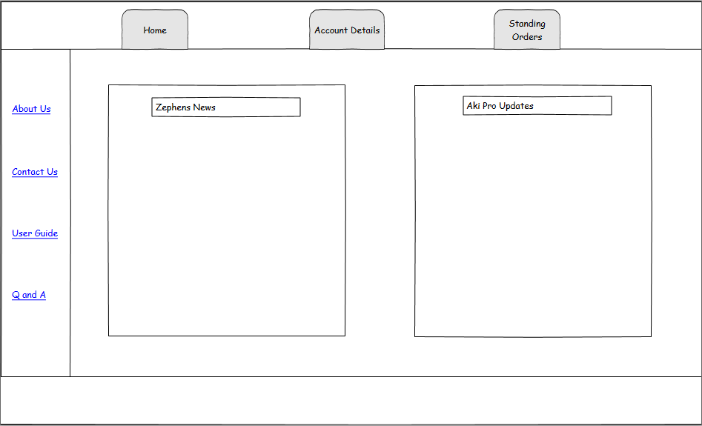

Account Details Page Fig 2

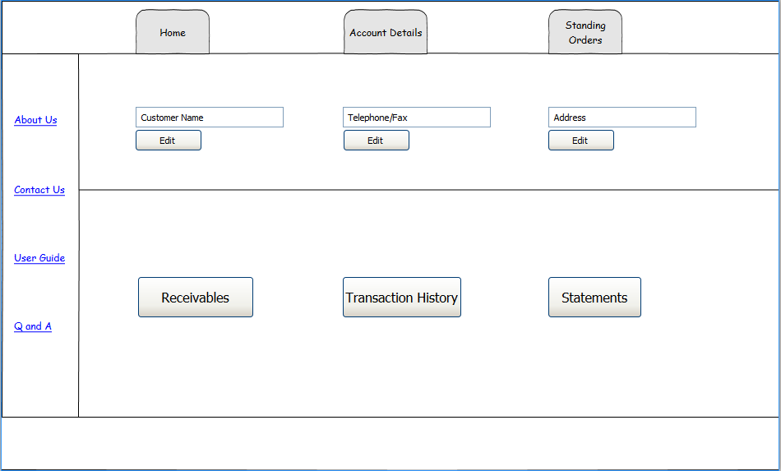

Standing Orders Page Fig 3

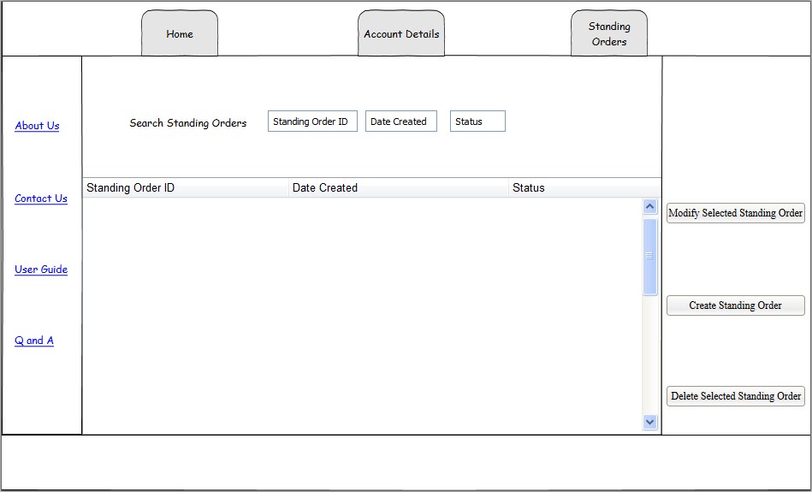

Modify Standing Order Page Fig 4

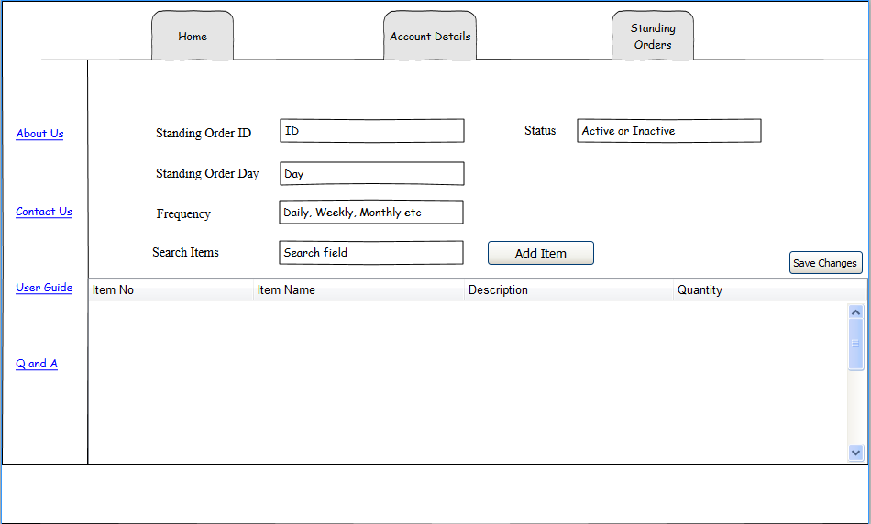

Create Standing Order Page Fig 5

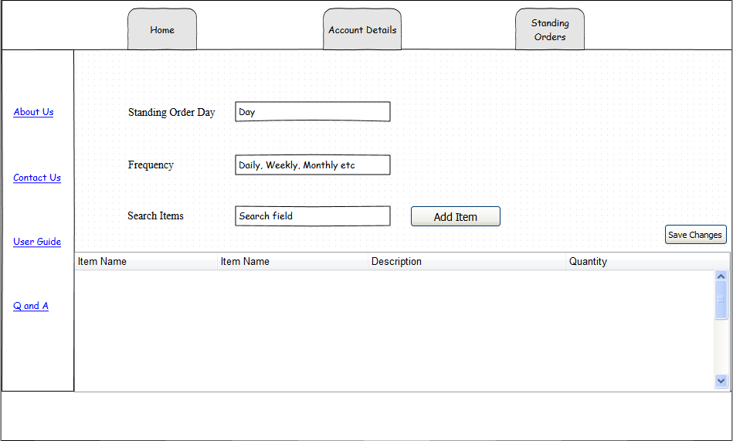

AkiProPlus Driver’s Application Interface Design

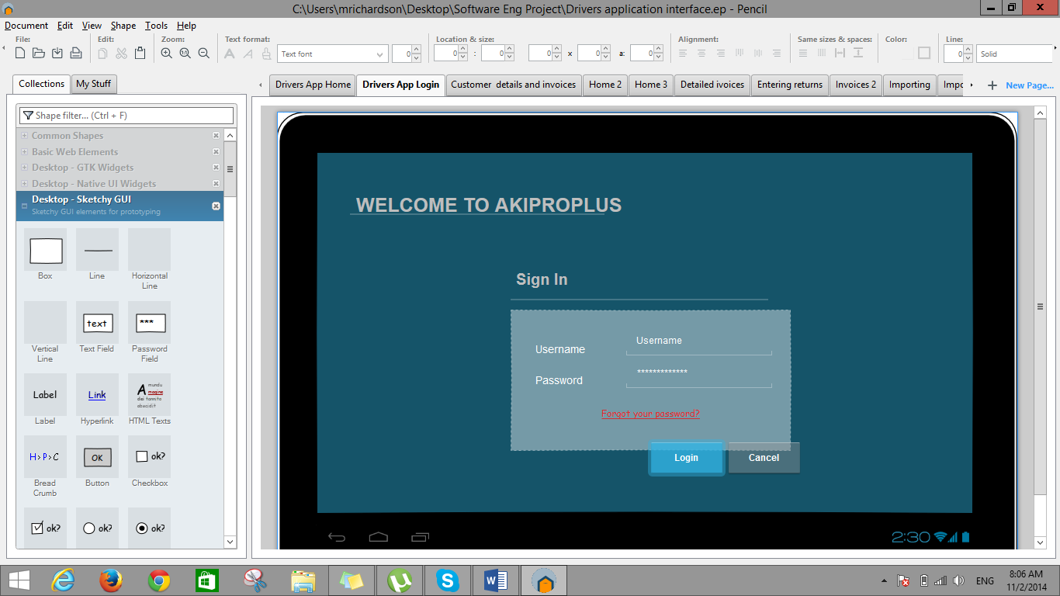

Figure 1: Login page

Description:

In figure 1 above demonstrates the login process of Akiproplus. The user would be assigned a username and password in order to enter the application and the system will verify the user’s credential. In the case where a user forgot their password, the “Forgot your password?” link will take the user to another page where the system will acquire the Driver’s ID for verification purposes, and allow them to reset their password.

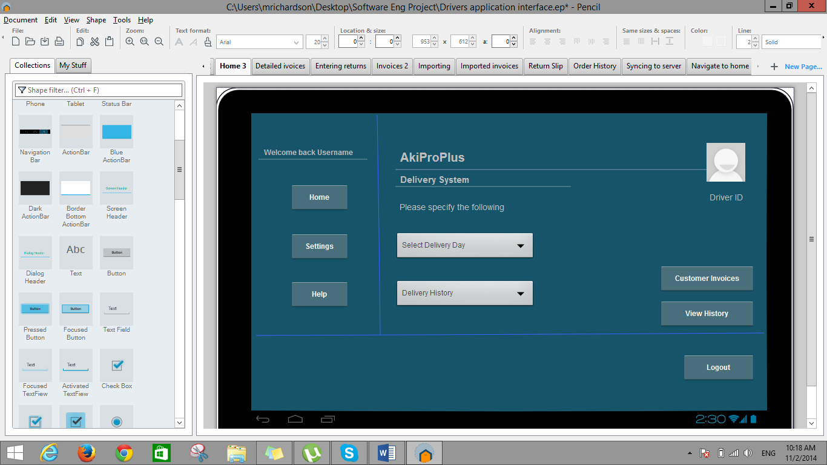 Figure 2: Homepage

Description:

Once the login credentials have been verified and the user have successfully logged into the application, they will be taken to the application’s homepage. The navigation bar for the application consist of a home, settings and help button. The home button will allow the user to navigate to the homepage displayed in figure 2 above once he’s on another page. The settings button will allow the user to perform functions such as changing their personal information that have been stored to their profile such as their username or password. Finally the help button should be able to assist the user in troubleshooting any problems the user can potentially encounter while using the application. At the footer of the application homepage there is a logout button. This button should allow the user to logout of the application once all daily operations are completed.

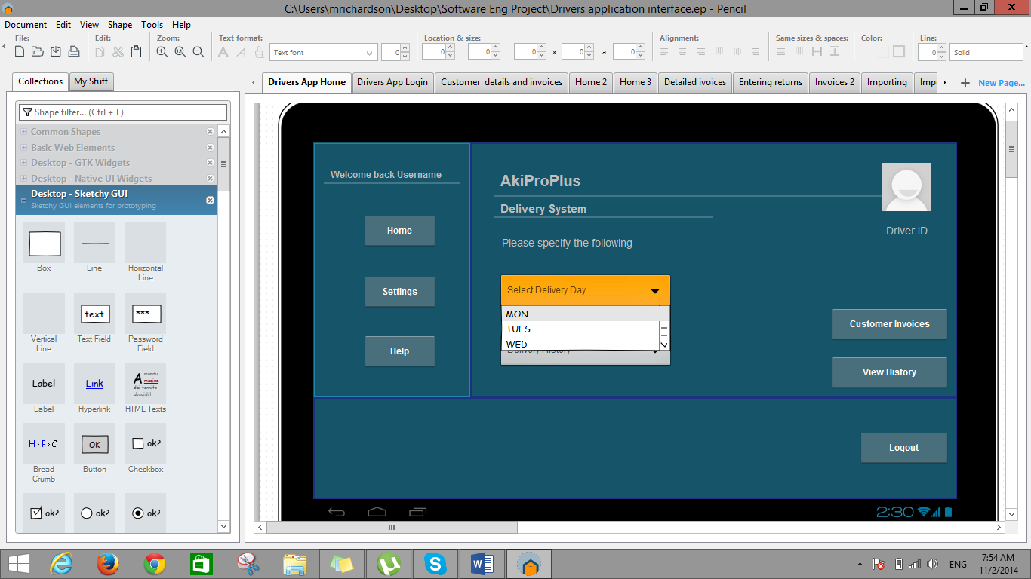

Figure 3: Importing Invoices

Description:

Figure 3 demonstrates the first stage on how a user will import customer invoices from the server to the user respective android terminal.

Step 1

* The user must select a day in which deliveries are to be made. In other words if he’s about to begin his daily operations for Monday he’ll select his delivery day as Monday.

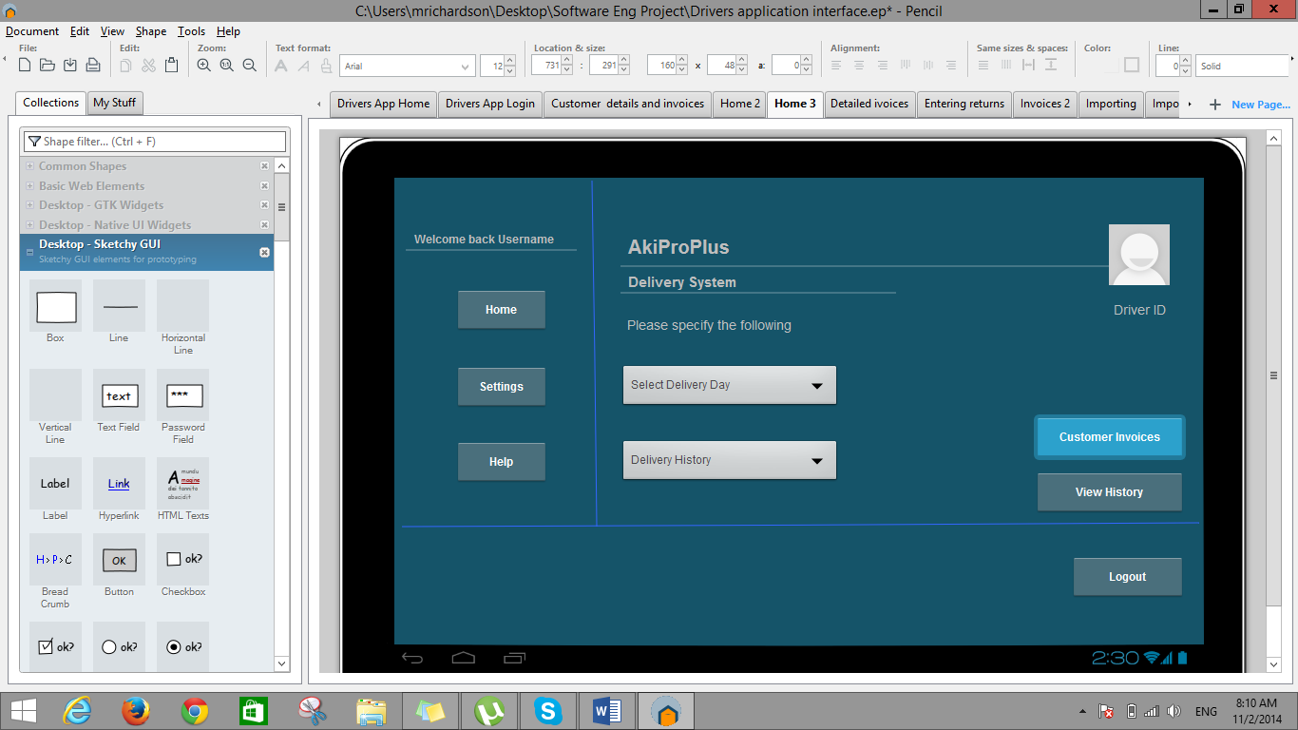

Figure 3.1

Description:

Step 2

* After the delivery day have been selected the user then clicks on the Customer Invoices button which will then navigate to a list of all invoices for the selected day

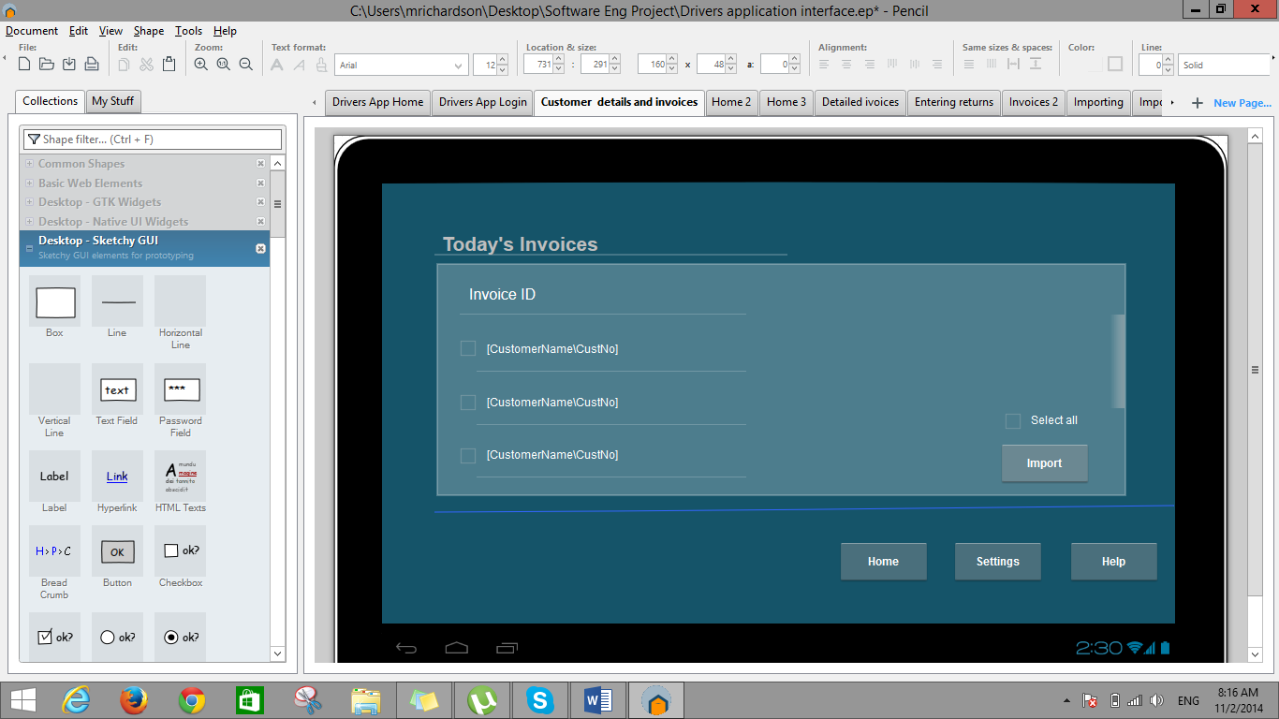

Figure 3.2

Description:

Step 3

* The user can now see the invoice listing of all customers for his specified delivery day and proceeds to import all these invoices from the server to his tablet terminal. It is crucial to note that this action of importing the invoices must be done before he proceeds to perform any of his daily operations.

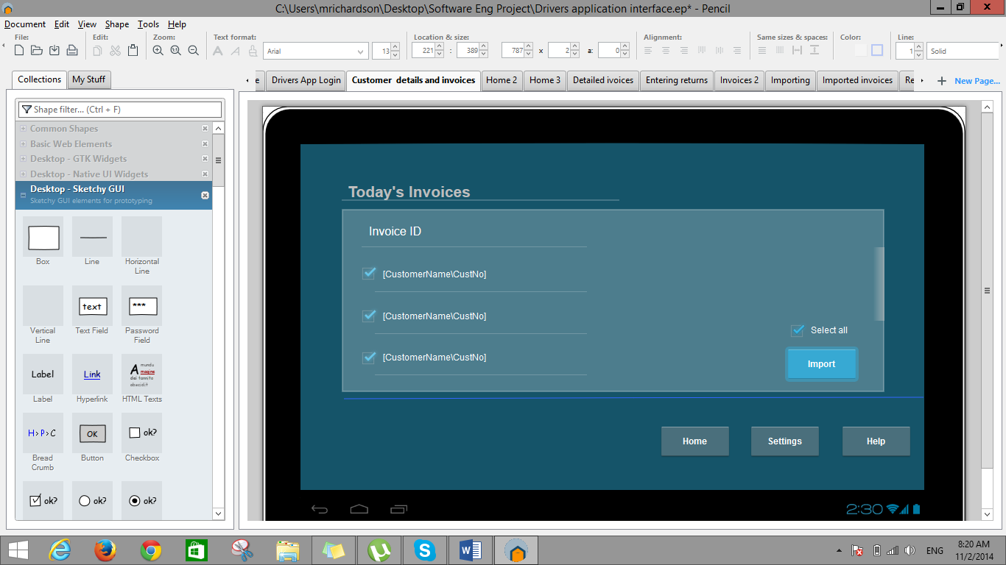

Figure 3.3

Description:

Step 2 (cont’d)

* The user can check each invoice individually and import them or simply check the select all box and then click on the import button to execute the import process.

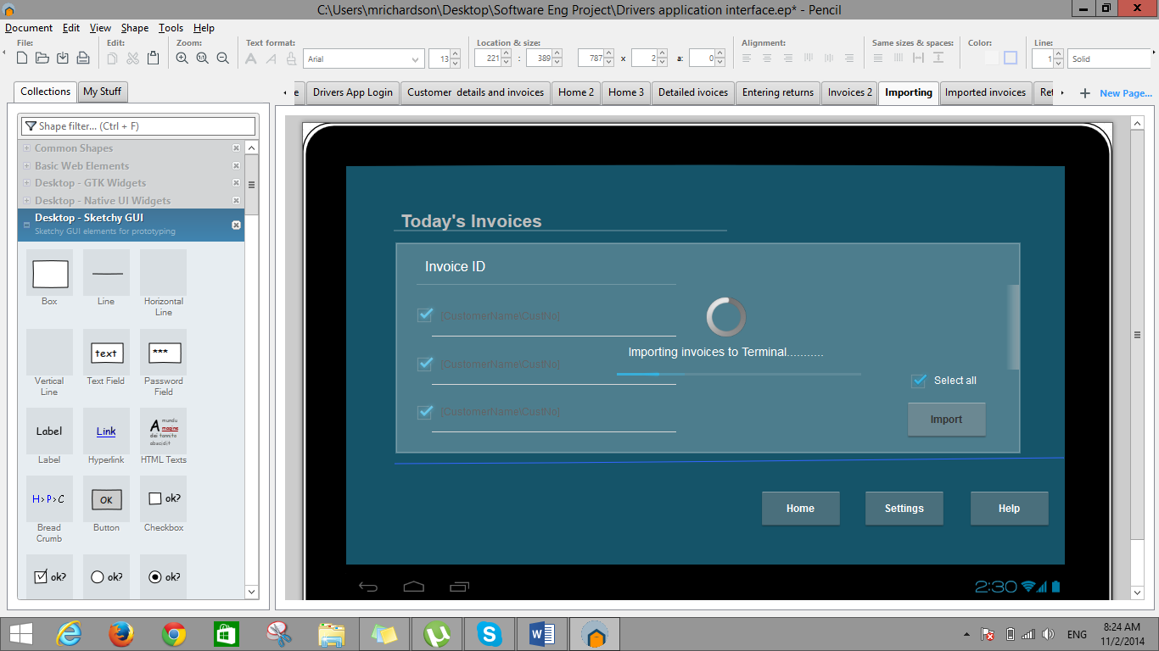

Figure 3.4

Description:

Step 2 (cont’d)

* The interface notifies the user that the invoices are in the process of being imported.

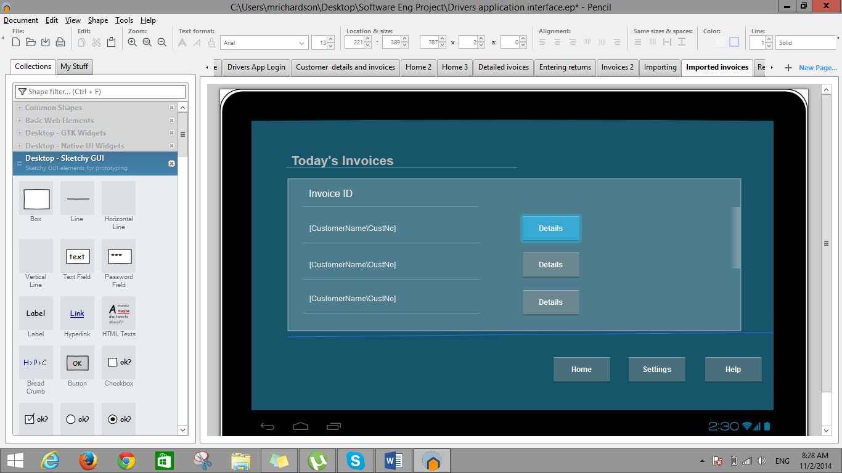

Figure 3.5

Description:

Step 2 (cont’d)

* Once the invoices have imported successfully the user should only see the interface displayed in Figure 3.5 when they click on the customer invoice button. This is due to the invoices already existing on the tablet for the specified day under the combo box for delivery day.

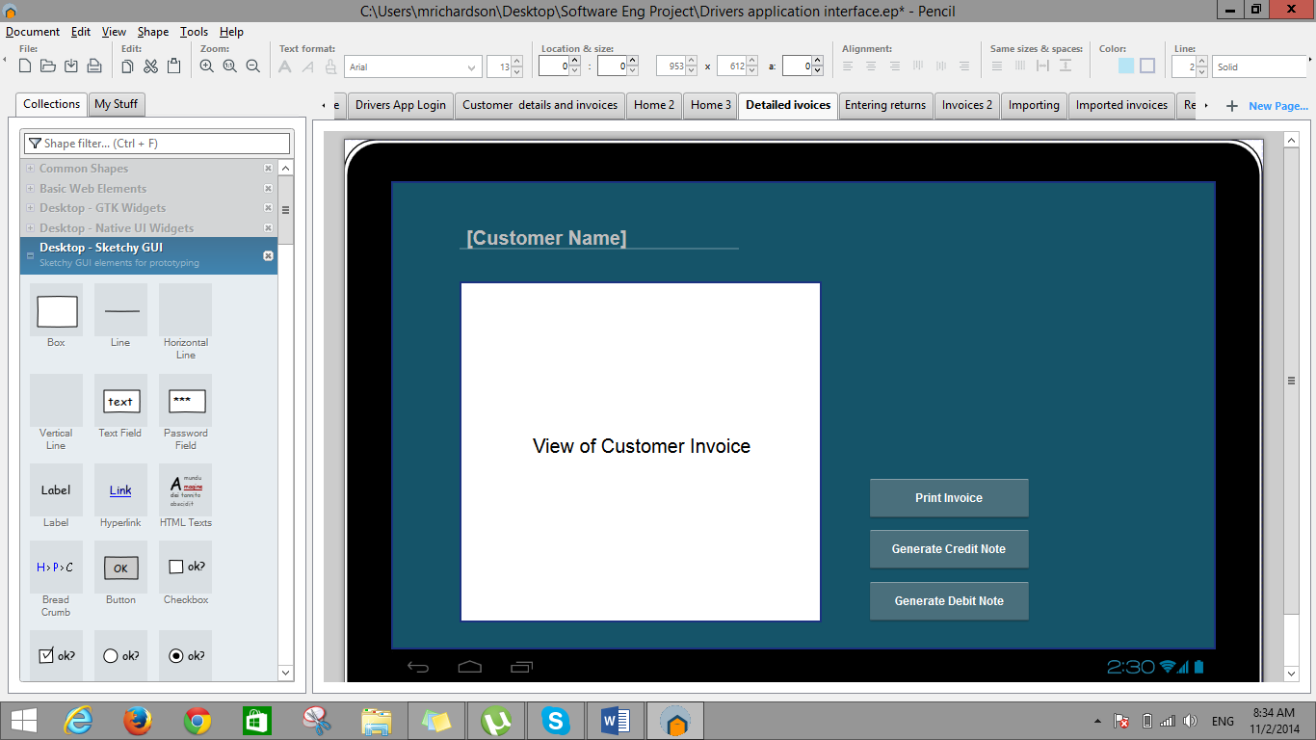

Figure 4

The user must click on the tablets back button to navigate to the previous page

Description:

* When the user clicks on the details button in figure 3.5 he’ll then see the interface displayed in figure 4. The user now have the option to print the invoice or in the case of a discrepancy generate a credit note or a debit note.

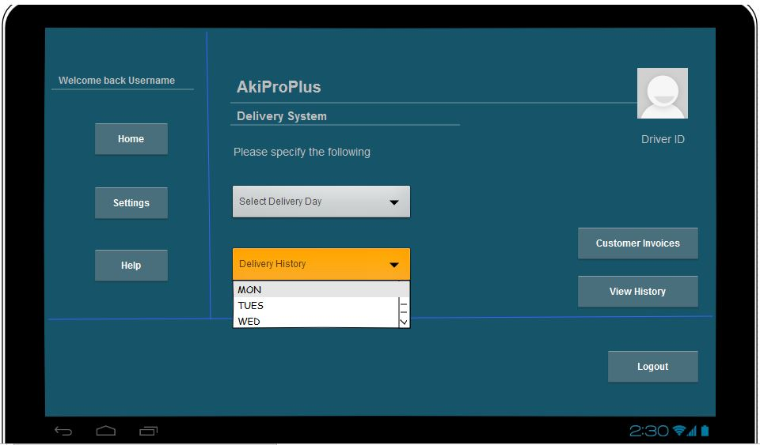

Figure 5: Importing delivery information on goods that have already been delivered

Description:

Step 1

* Figure 5 above demostrates how the combo box for delivery history functions. The user has the option to select a day from during the week. The day selected has to do with the shelf life of an item, so if an item shelf life is 3 days the user will select the day, 3 days from the current day.

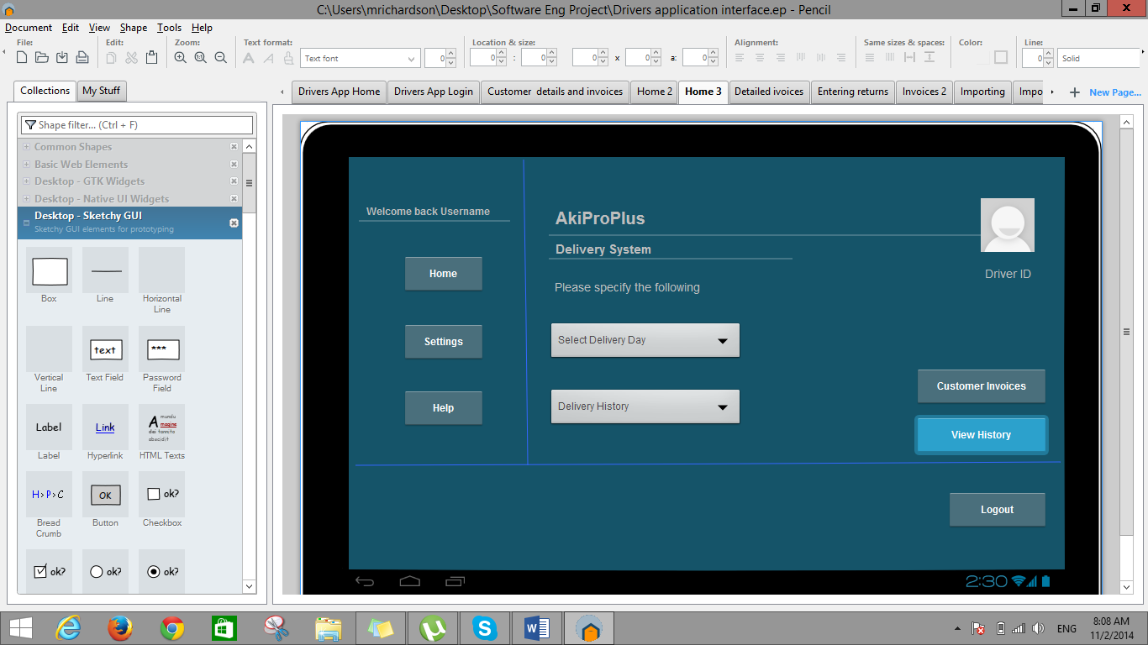

Figure 5.1

Description:

Step 2

* After the day has been selected the user then clicks on the view history buttons where he should see the listing of items that were delivered on the day specified under the delivery history combo box.

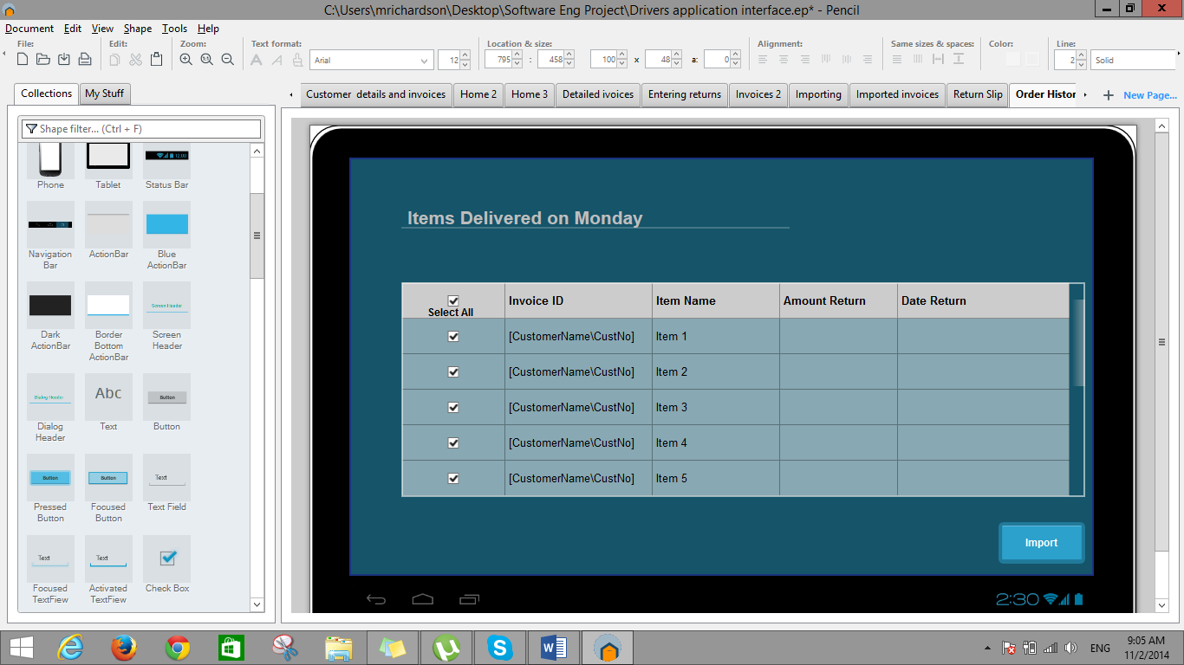

Figure 5.2

Description:

Step 3

* The user now has to import this information from the server to the terminal of the tablet by clicking the import button.

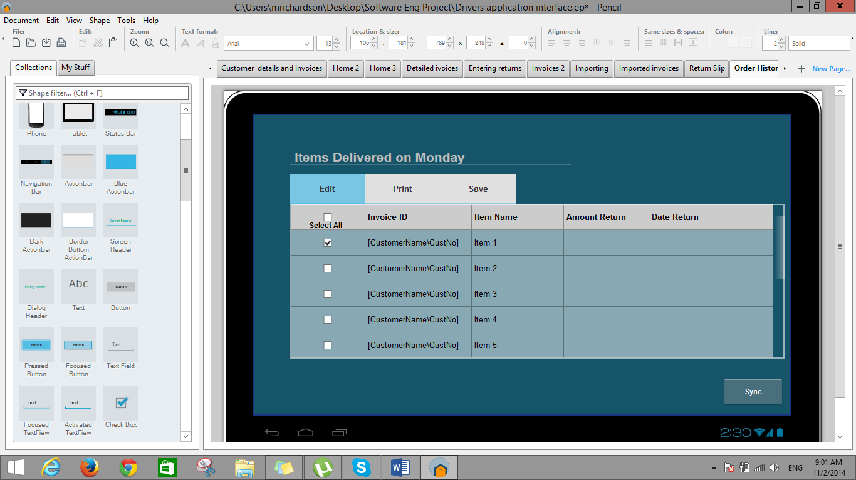

Figure5.3

Description:

Step 4

* Once the information was imported successfully the user should only see the interface displayed in Figure 5.3 when they click on the view history button. This is also due to the information already existing on the tablet for the specified day under the combo box for Delivery history.
* The user now have the options of editing, printing and saving this information once the information was imported.

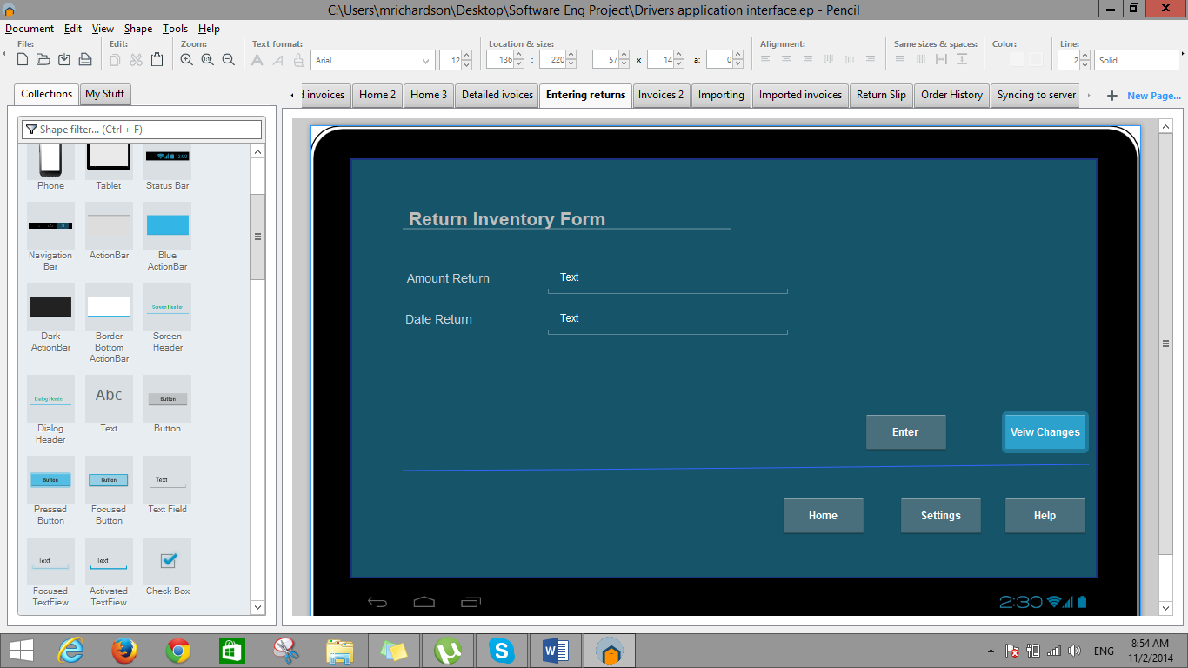

Figure 5.4

Description:

Step 5

* If the edit option was selected a form will appear for the user to enter the necessary information on a selected item and adjust accordingly. To view the changes made to the information, the user can then select the view changes button, where he can continue editing and saving the information.

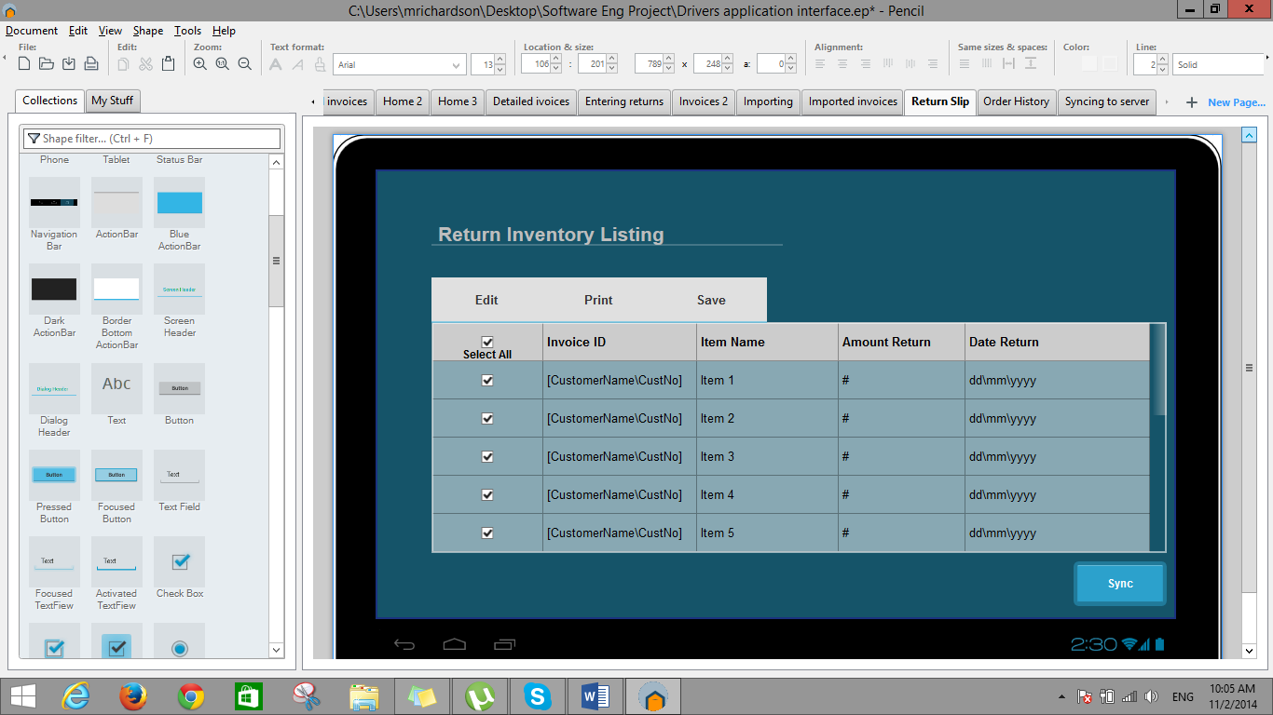

Figure 5.5

Description:

Step 6

* Once all changes have been entered, verified and saved the user can now proceed to synchronize the information to the main server. Synchronization will only be executable when the user have return to the bakery’s premesis.

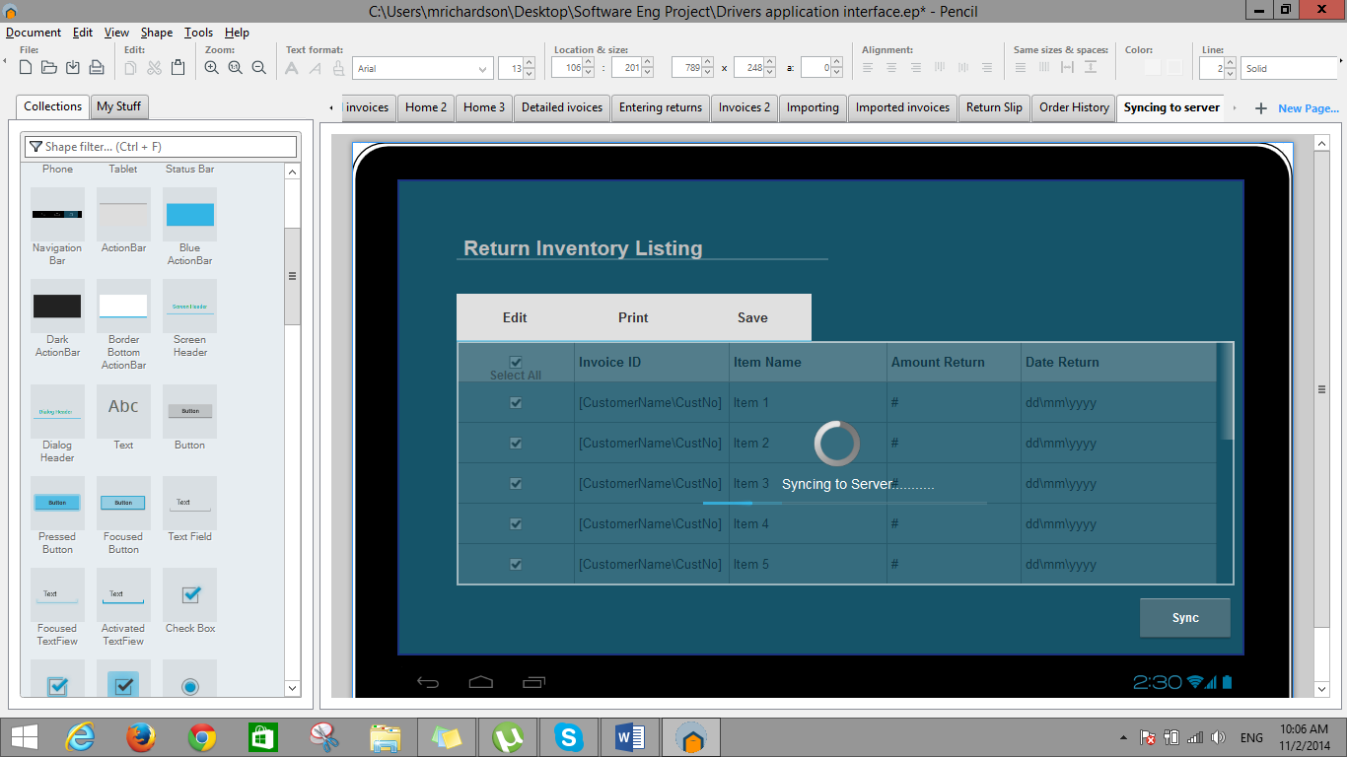

Figure 5.6

Description:

Step 7

* The interface in figure 5.6 shows the progress of the information being synchronized.

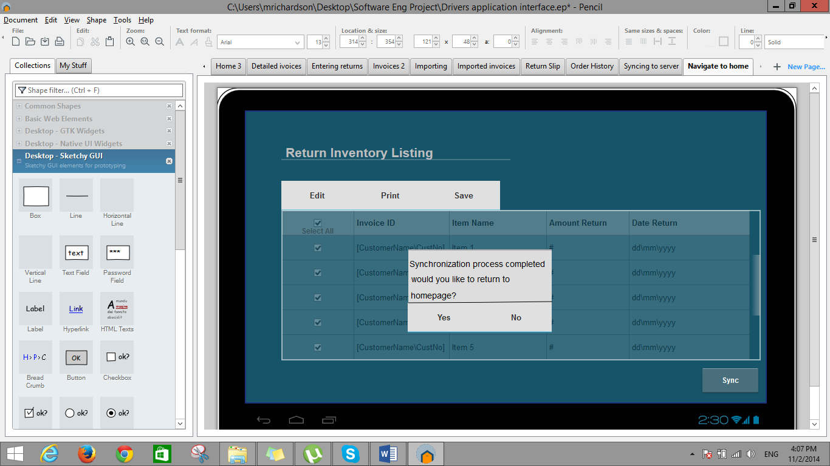

Figure 5.7

Description:

Step 8

* When the process is completed the application will now request if the user will like to navigate to the homepage. Mainly for them to logout of the application since the synchronization process is the final operation of their daily operations.

Sales Rep Application User Interface

Fig 1- Log On Screen

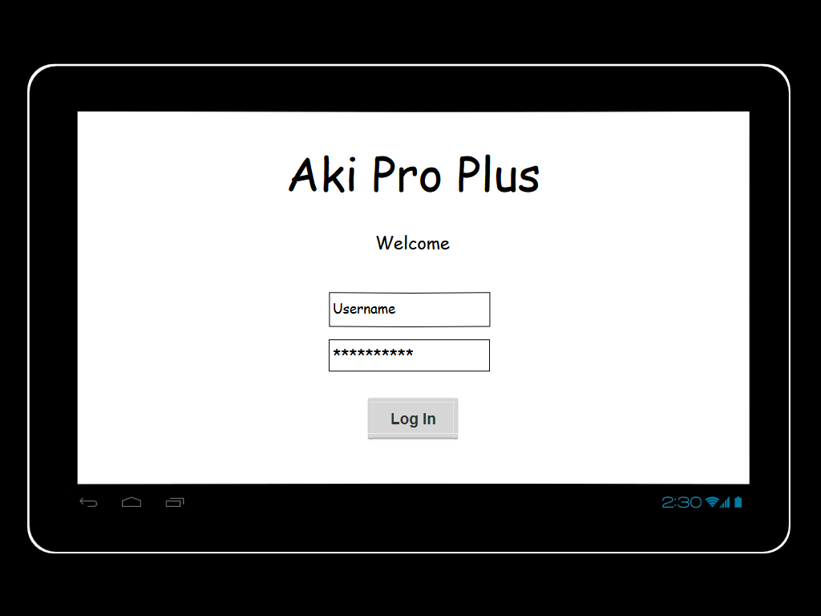

Fig 2- Home Screen

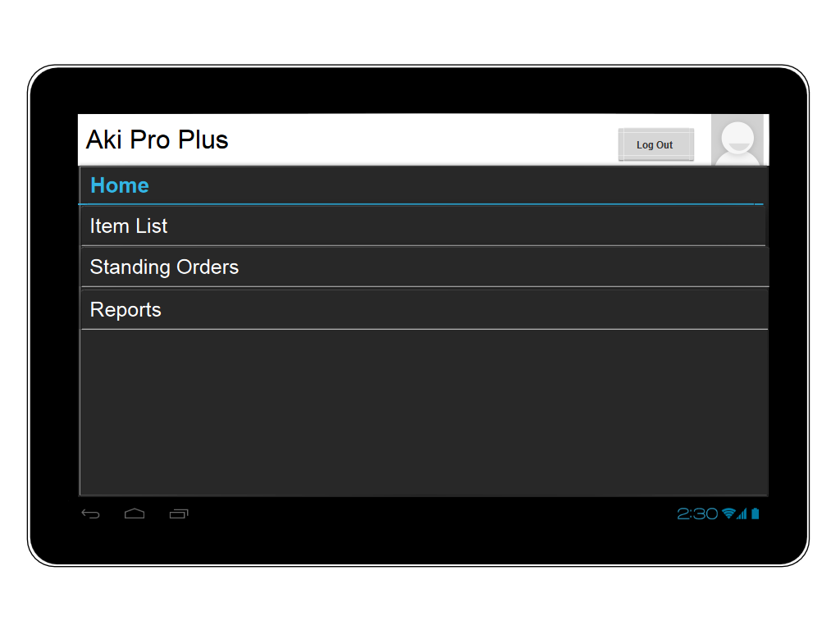

Fig 3- Item List Screen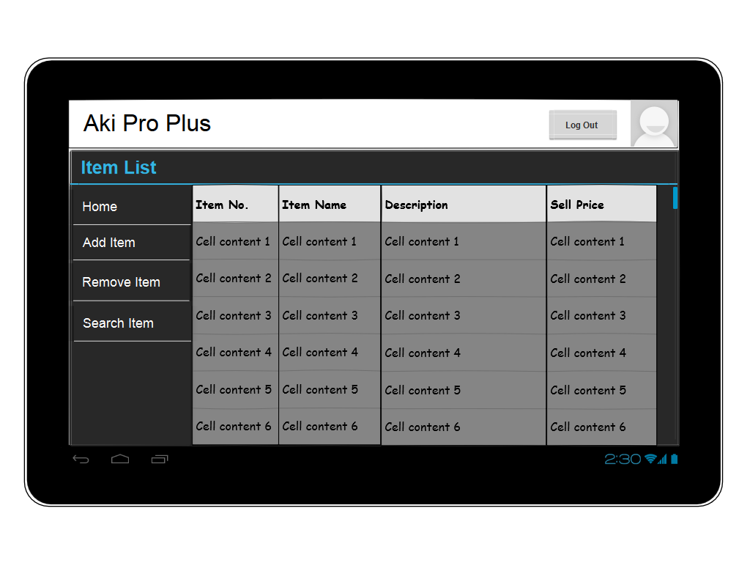

Fig 4- Add Item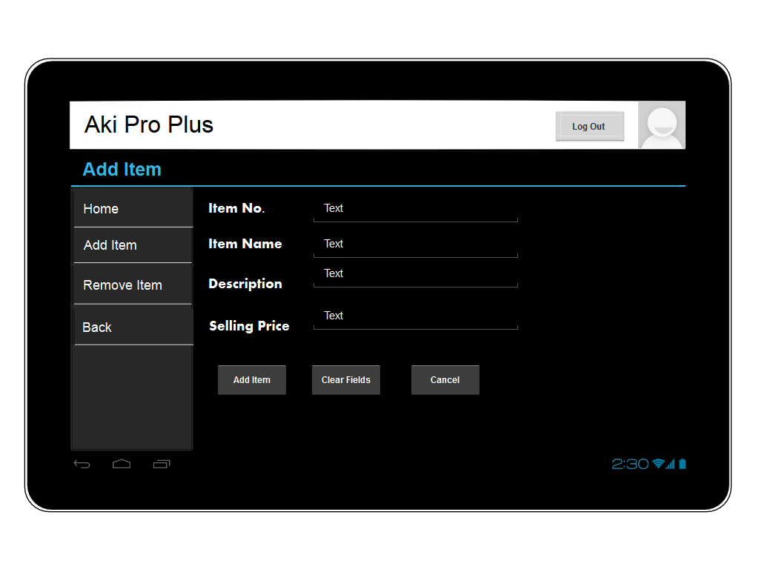

Fig 5- Remove Item

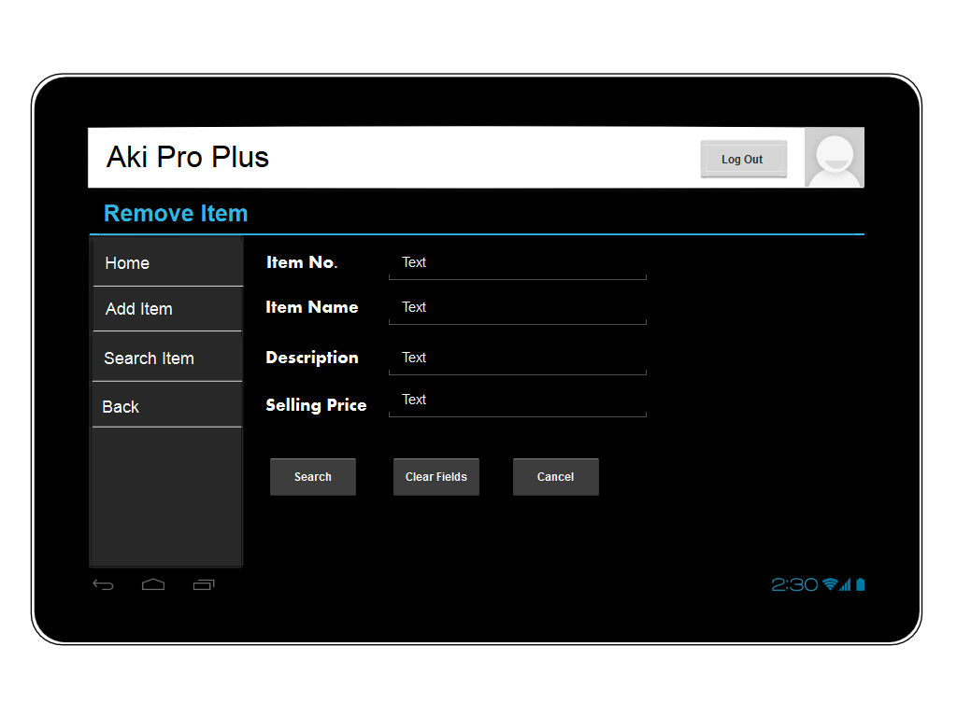

Fig 6- Remove Item (After Search)

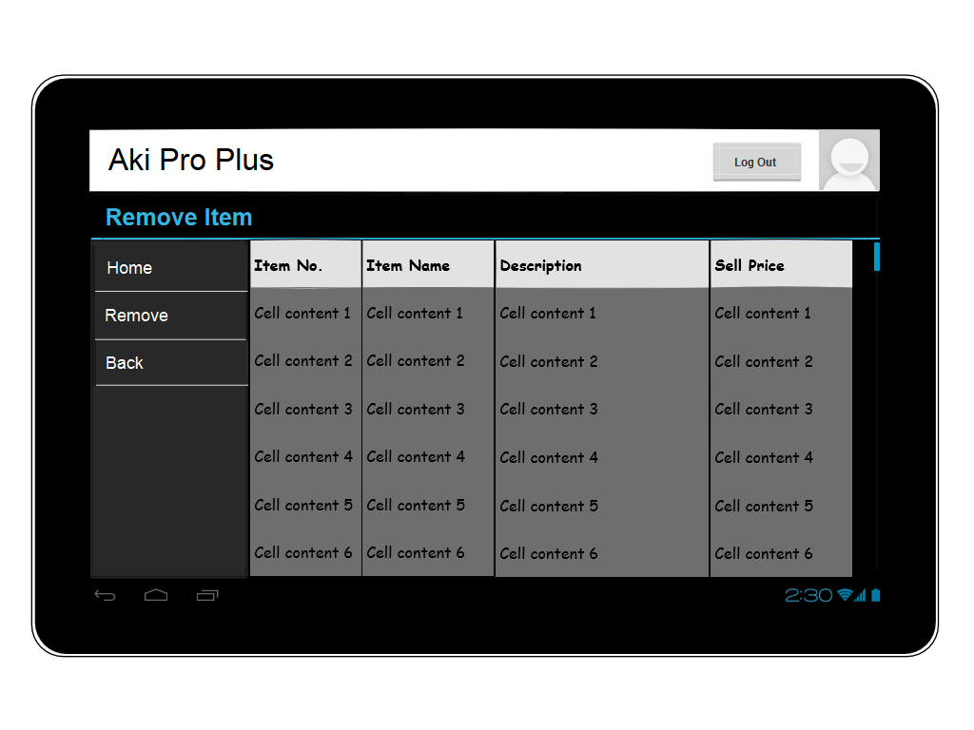

Fig 7- Reports Screen

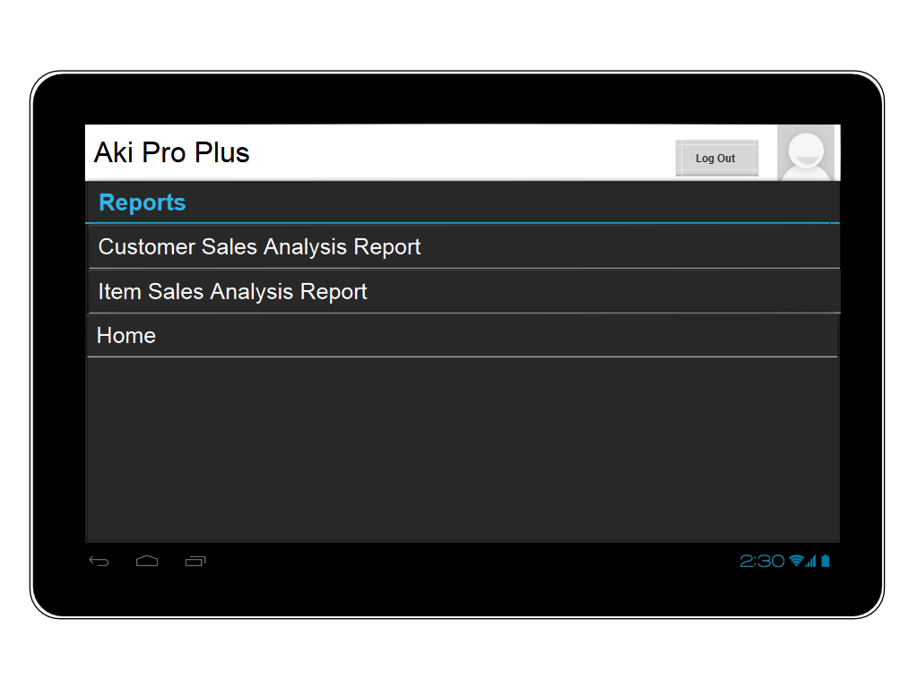

Fig 8- Standing Orders Screen

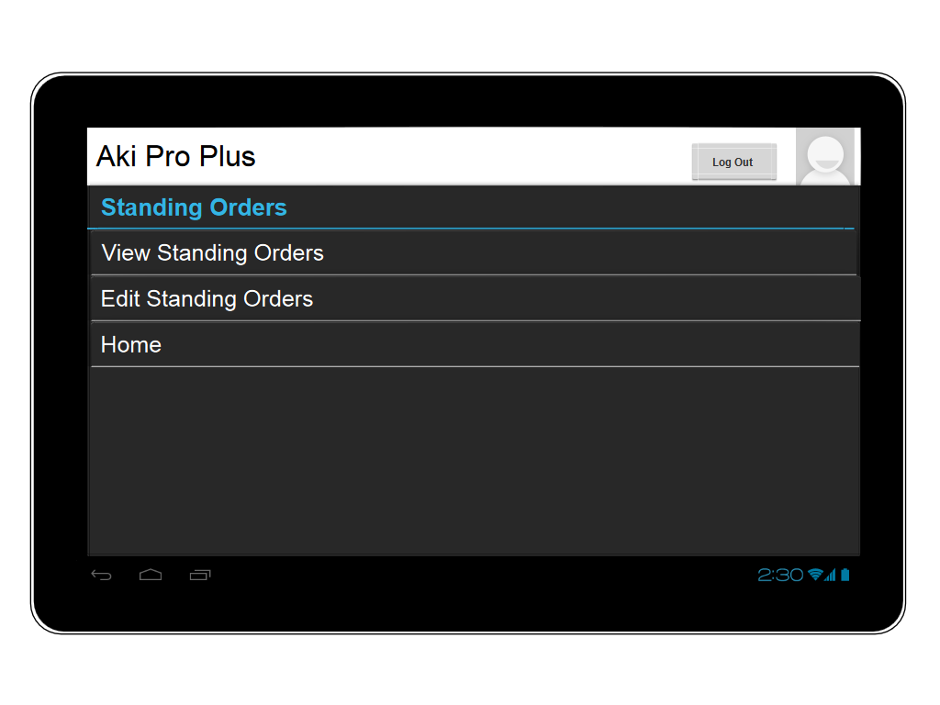

Fig 9- Edit Standing Order

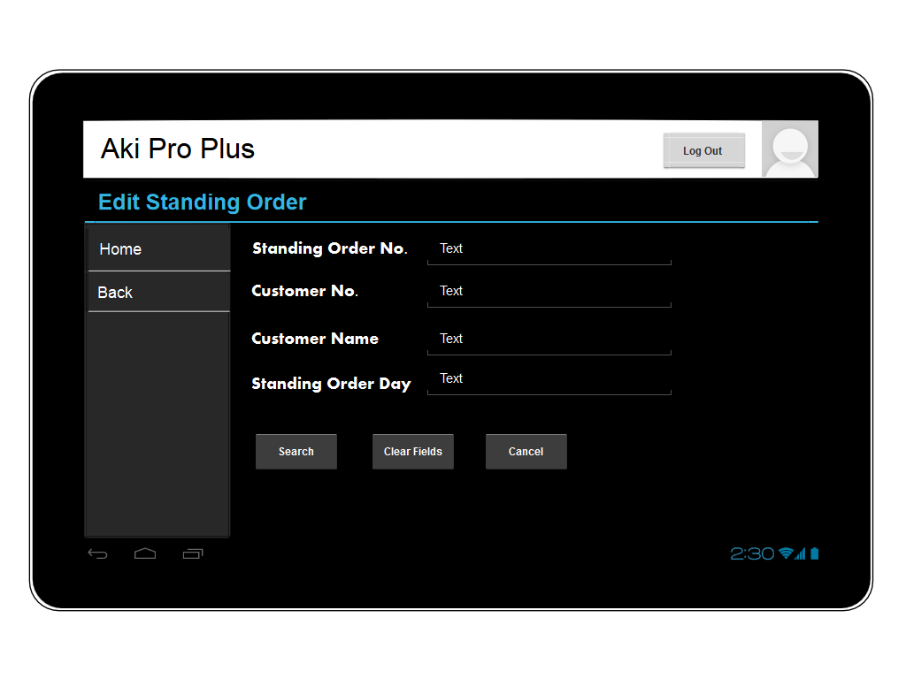

Fig 10- Edit Standing Order (After Search)

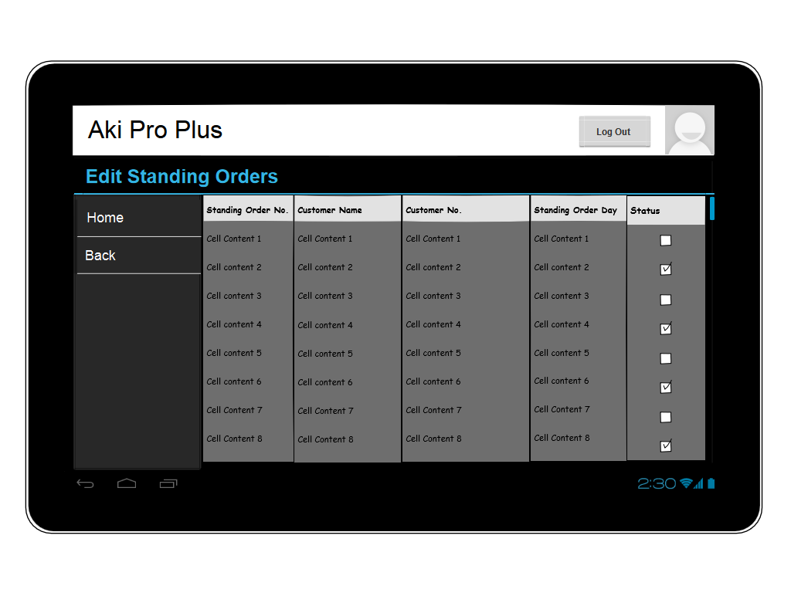

Fig 11- Edit Standing Order (After Selecting a Standing Order)

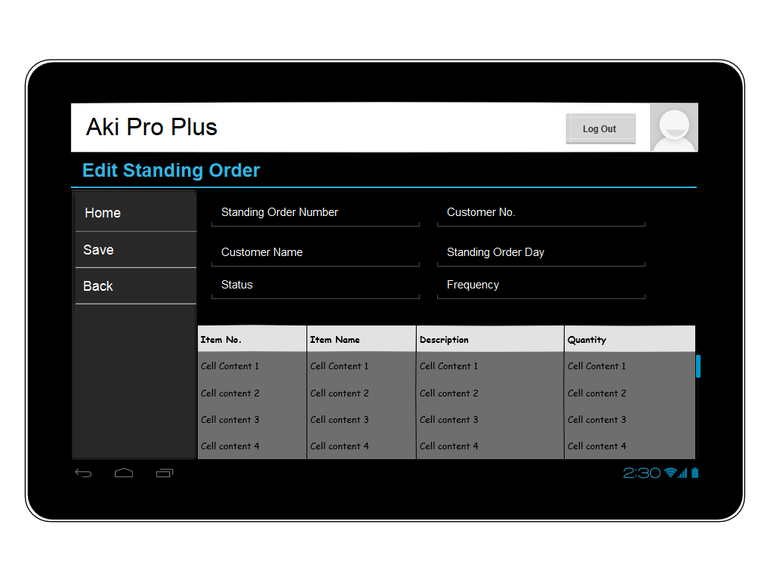

Fig 12- View Standing Order

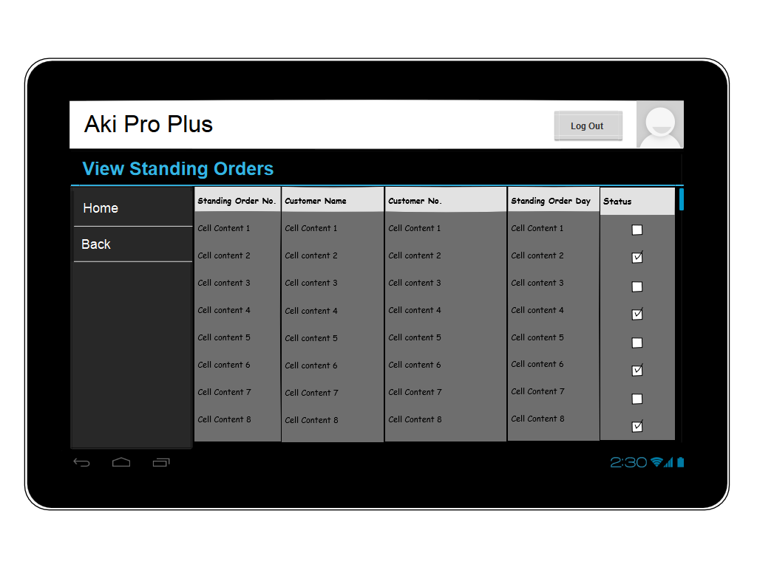

Fig 13- View Standing Order (After Selecting a Standing Order)

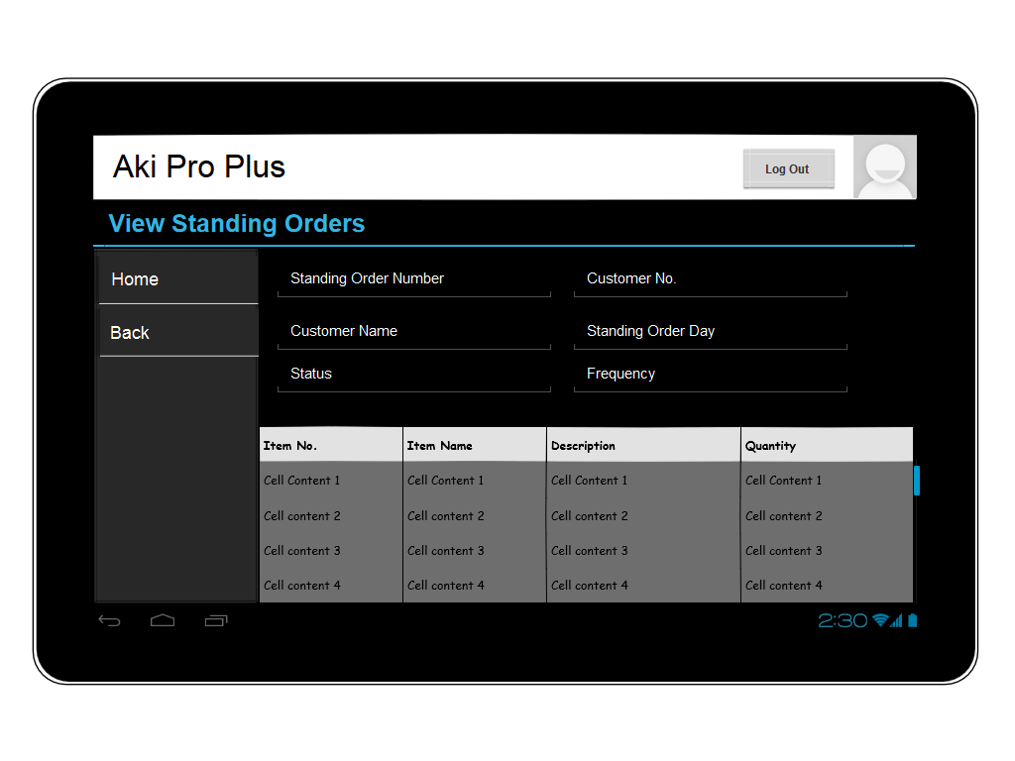

Order Processing

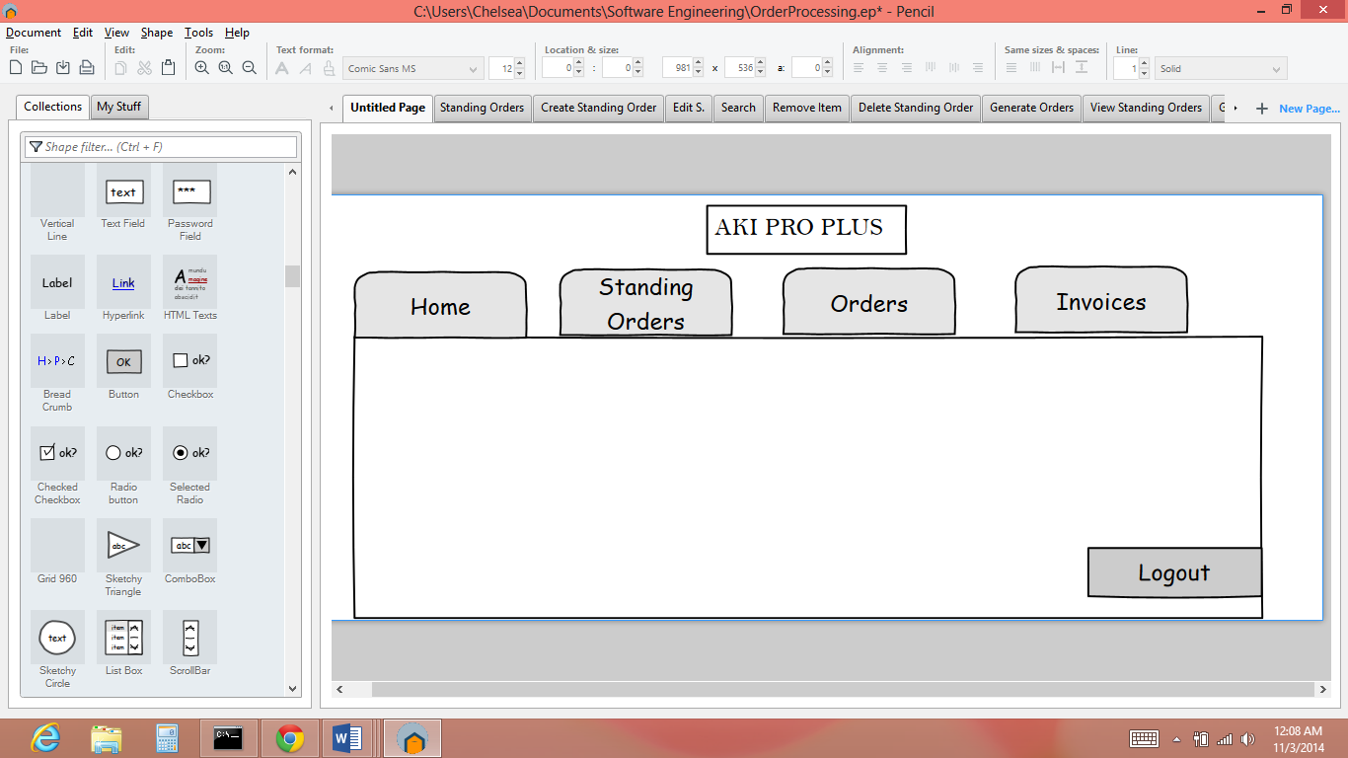

Figure 1: Describes the login Screen.

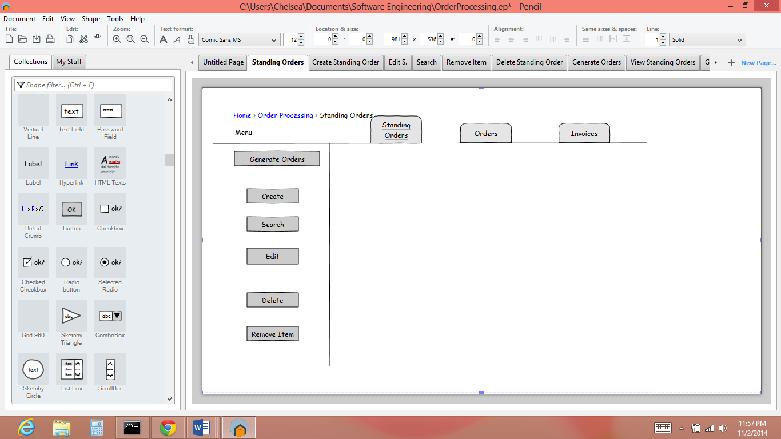

Figure 2: Displays what happens when the user selects the staning order tab.

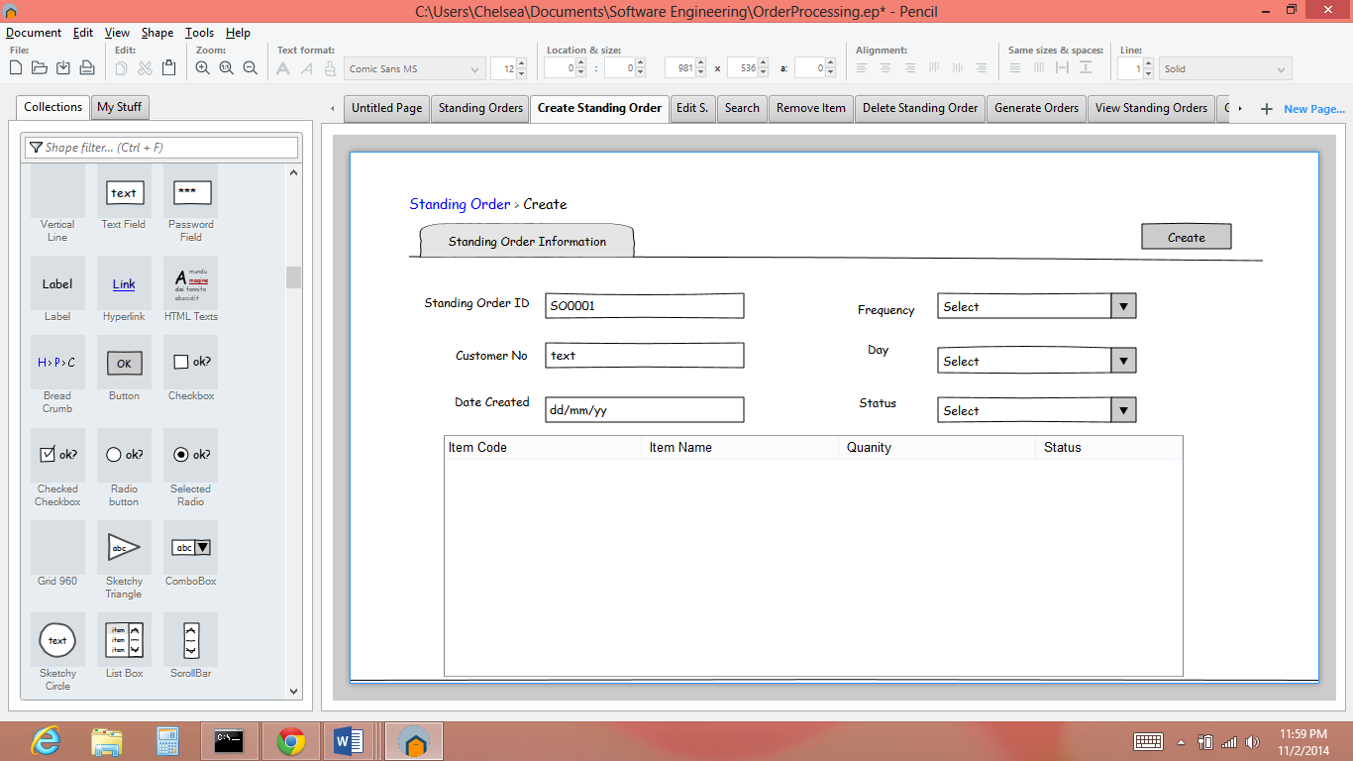

Figure 3: Displays how a user creates a standing order when they select the create button.

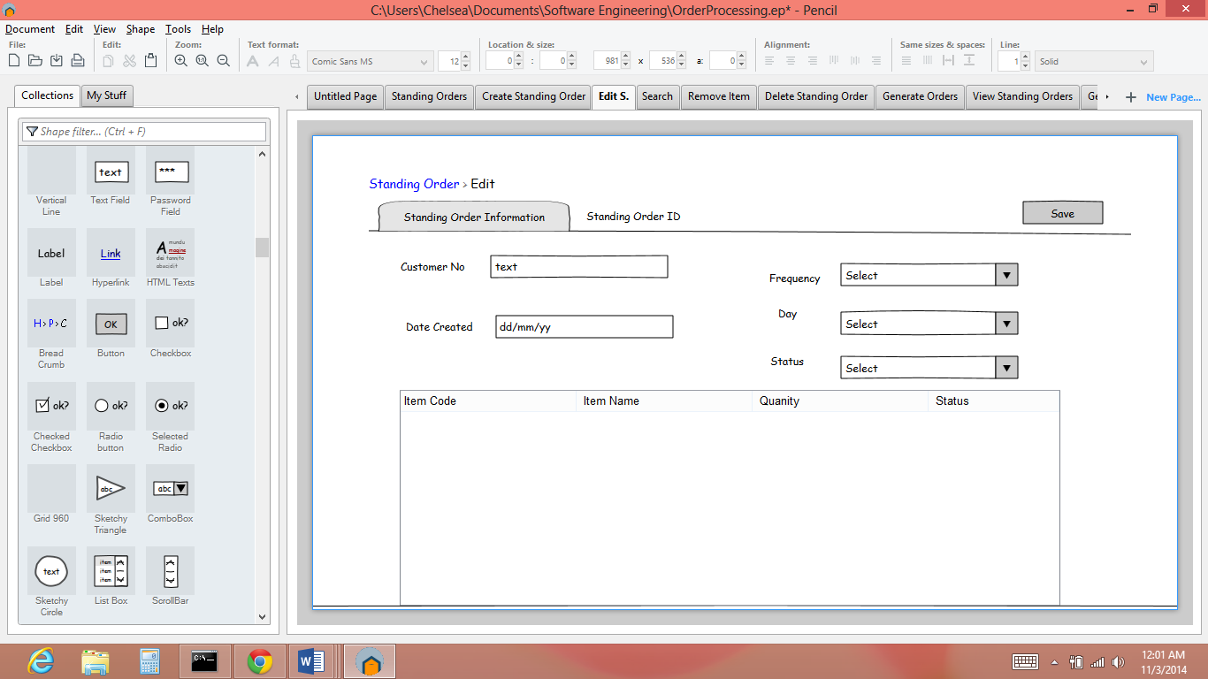

Figure 4: When the user selects the edit button they are directed to the screen above.

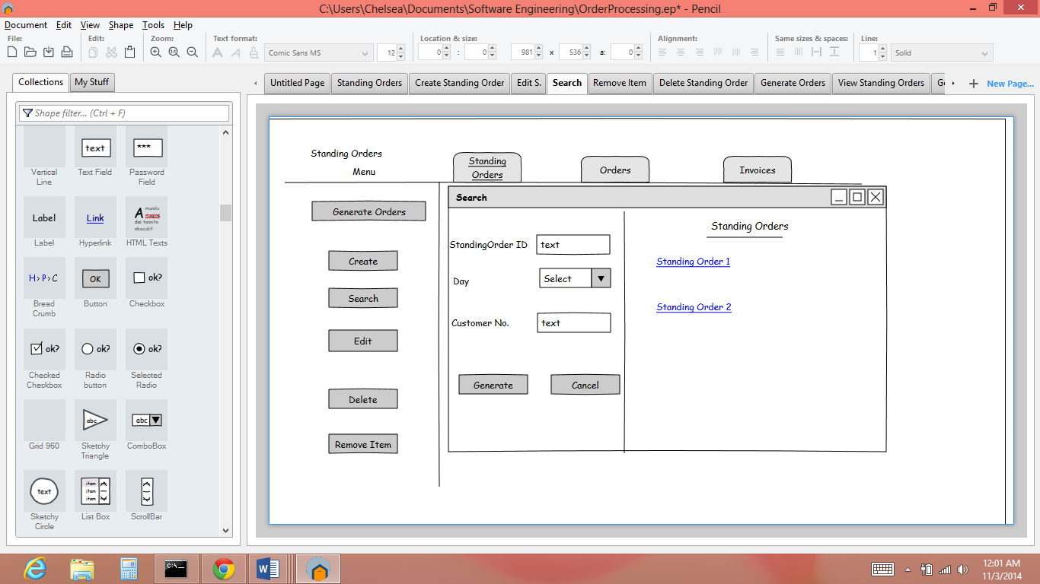

Figure 5: Displays the search window that appears when the user selects the search button.

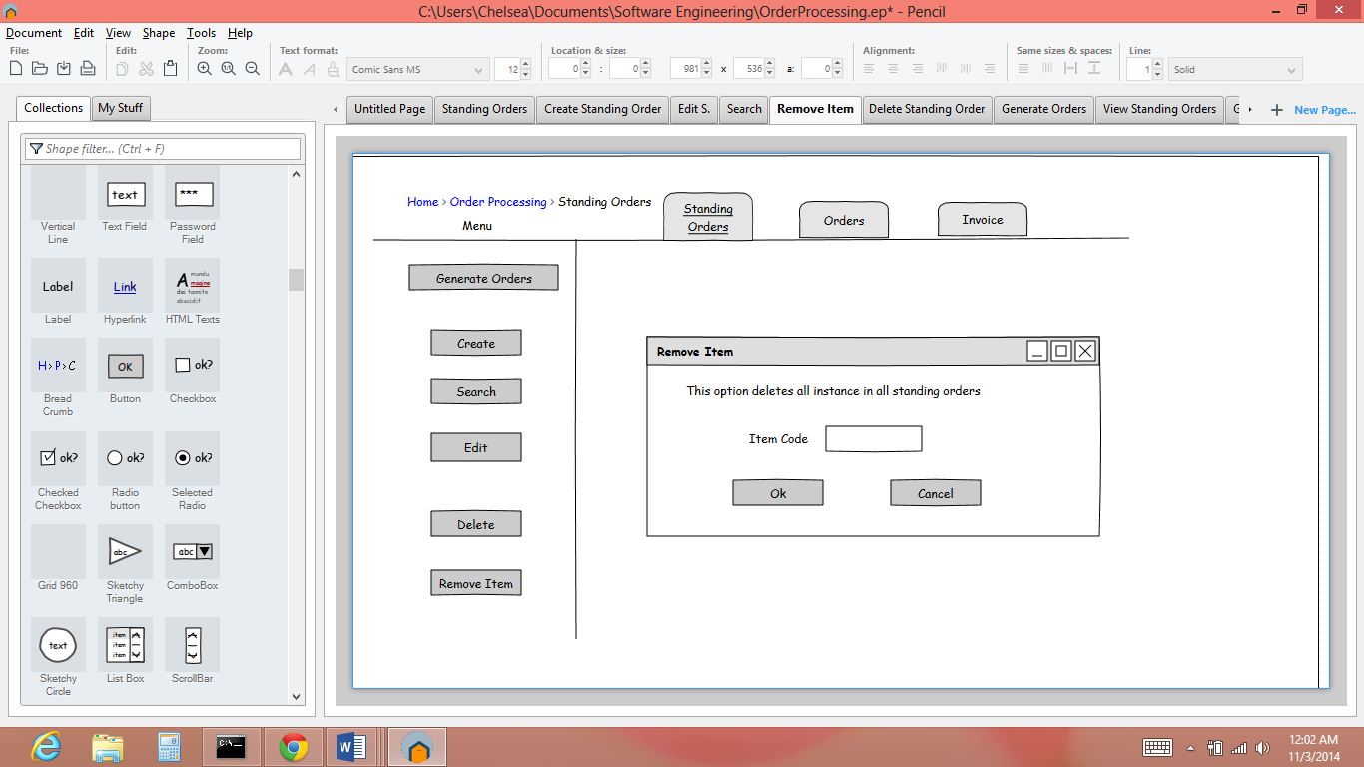

Figure 6: Displays the Remove Items window when the user selects the remove item button to remove an item from all standing orders.

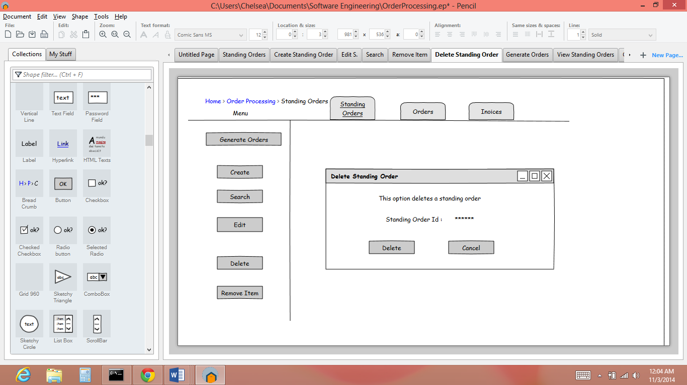

Figure 7: Displays the delete window when the user selects the delete button to delete a standing order.

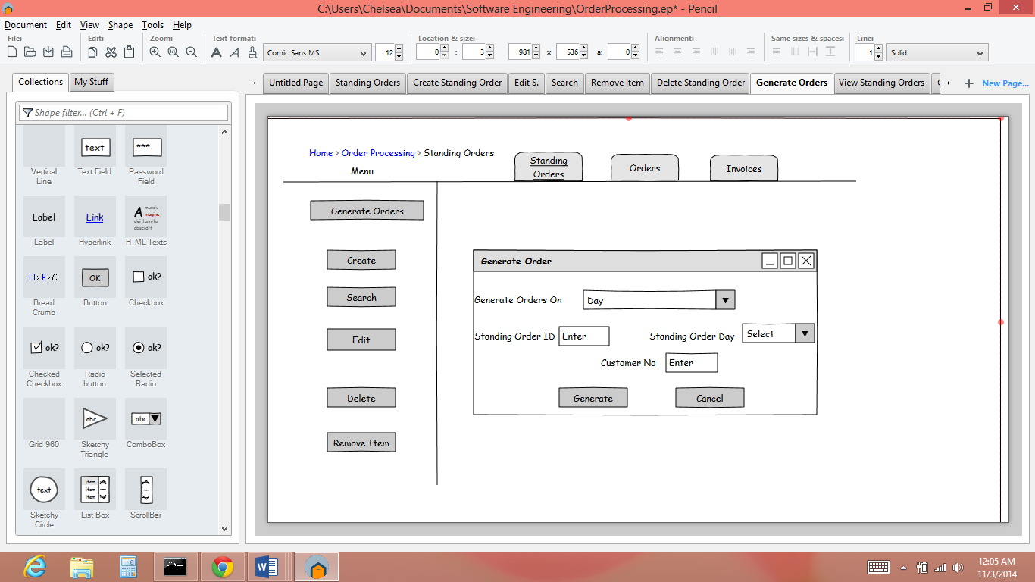

Figure 8: Displays the generate order window here the user has the option to generate a single standing order (enter standing order ID) or more (enter day or customer no).

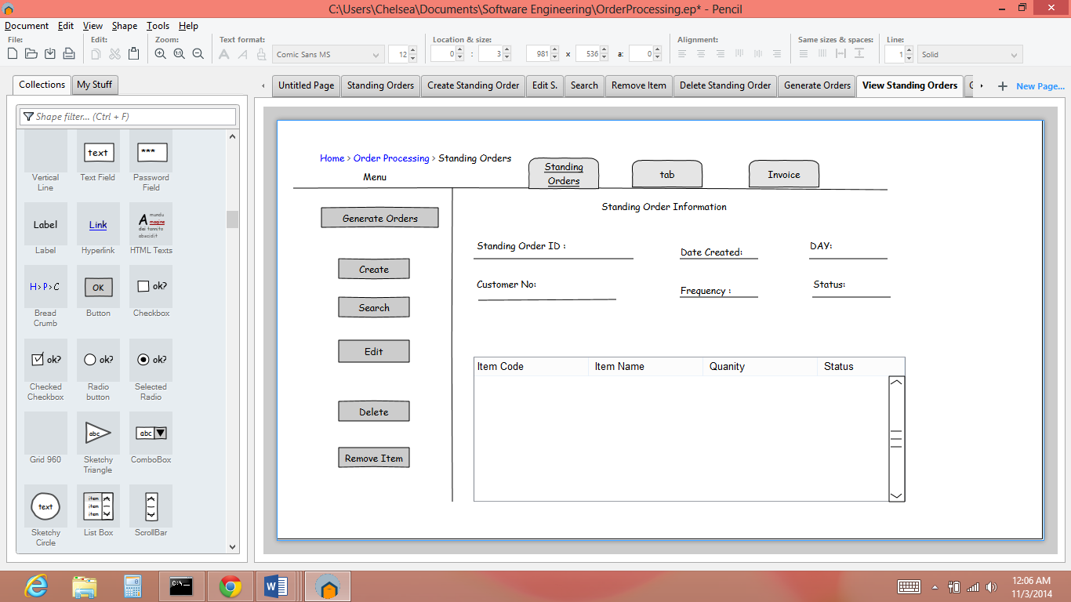

Figure 9: Displays a standing order in full detail when the user generates a standing order using the search option.

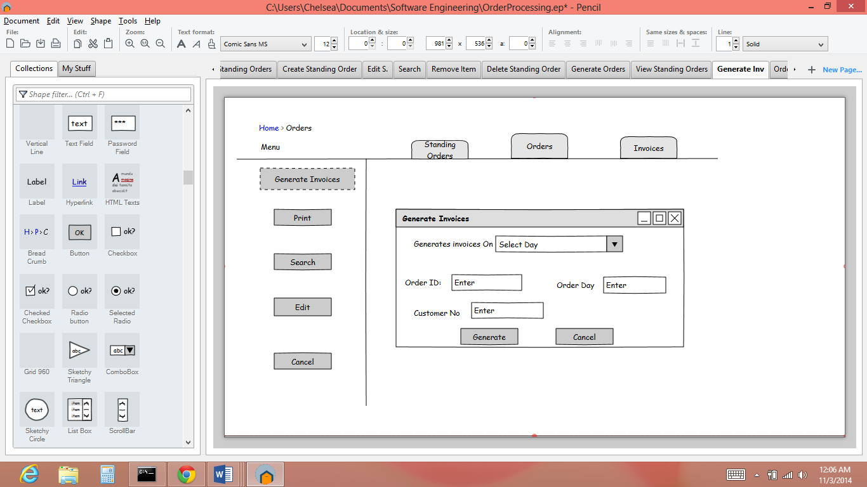

Figure 10: Displays generate invoice window.

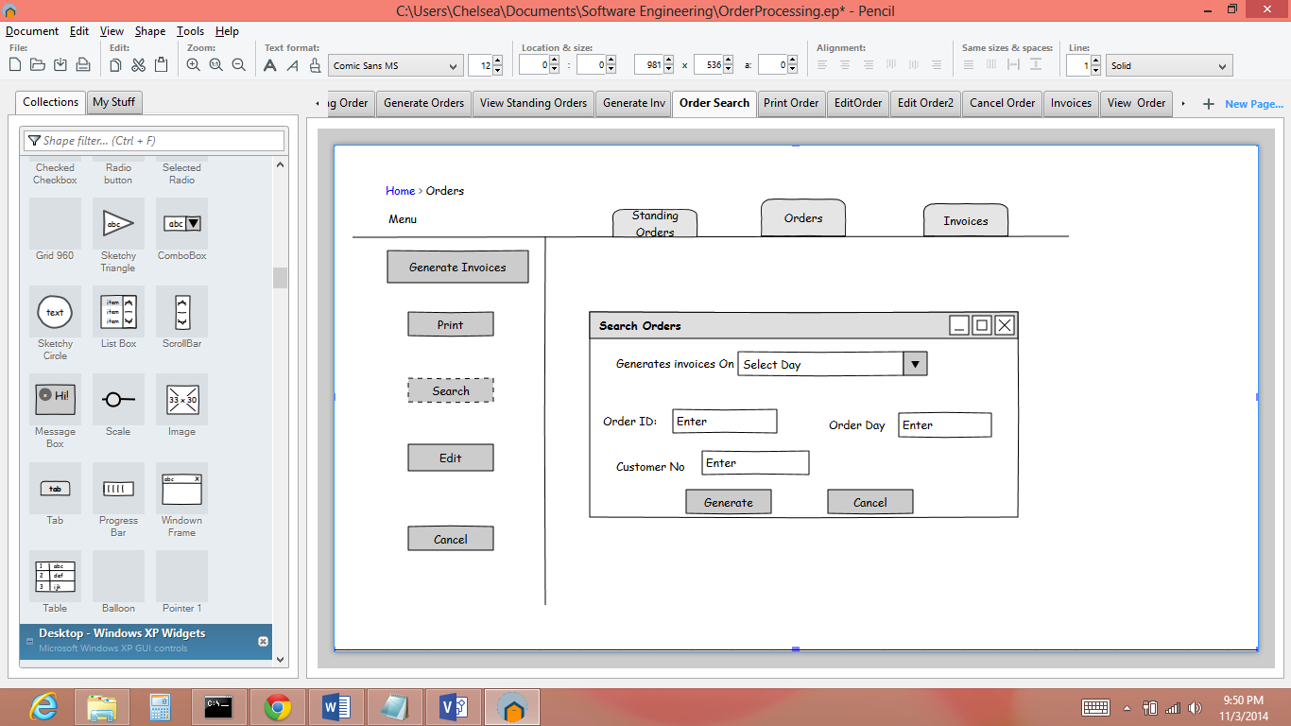

Figure 11: Displays the search orders window when the user selects the search button.

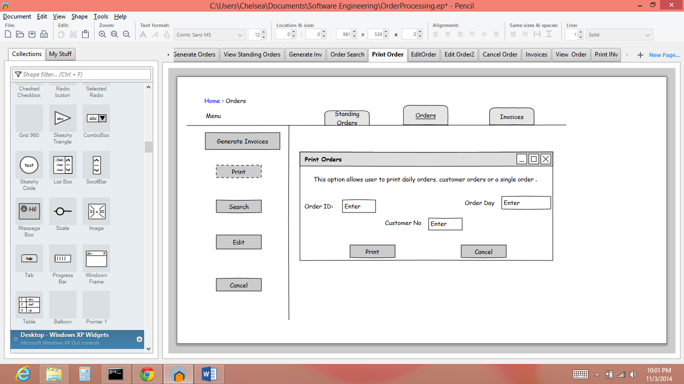

Figure 12: Displays the print window when the user selects the print button.

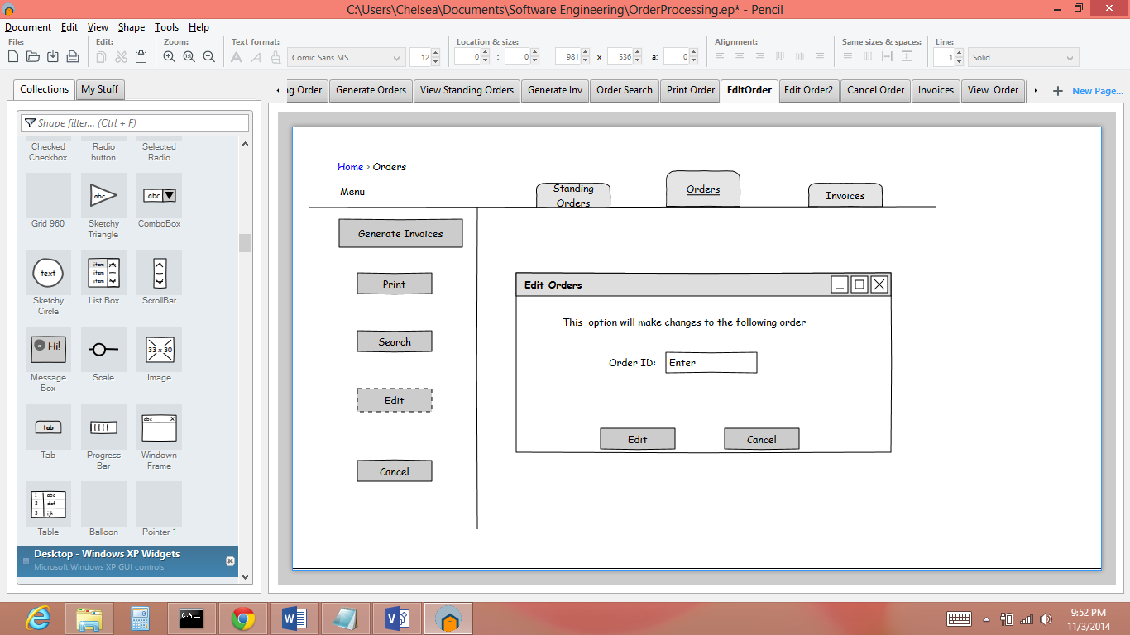

Figure 13: Displays how the user selects the order they want to edit.

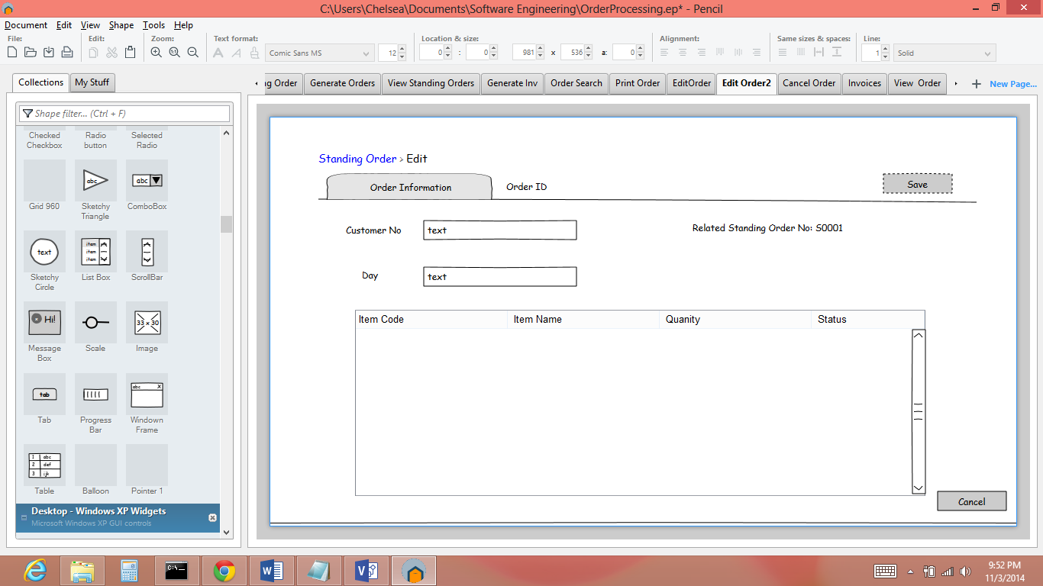

Fig 14: Displays the full order edit screen where the user would save the changes using save button.

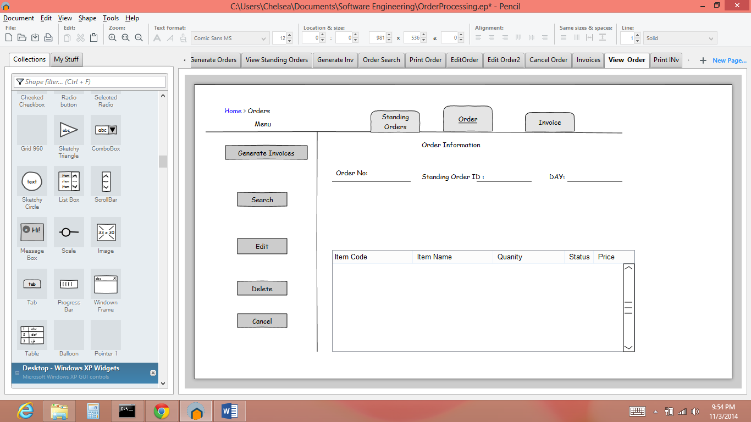

Fig 14: Displays an order in full detail after it is generated by search option.

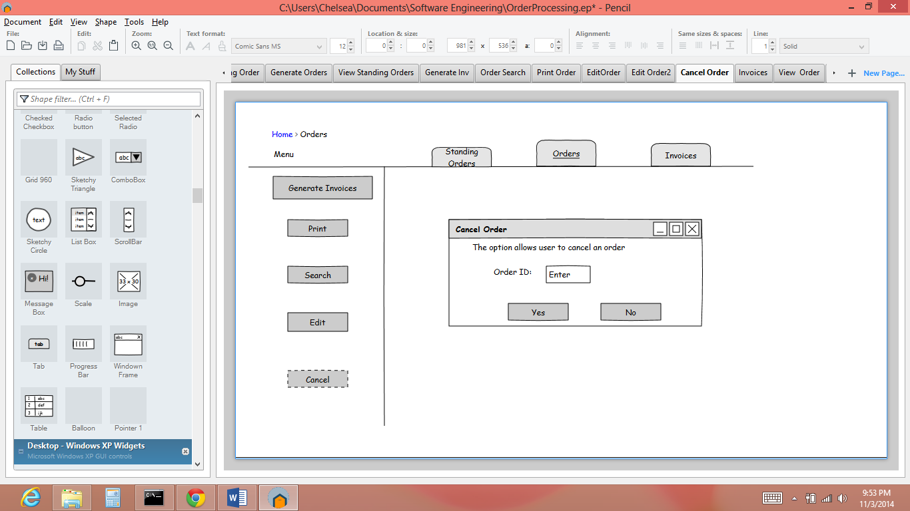

Fig 15: Displays the Cancel Order window which appears when the user selects the cancel option.

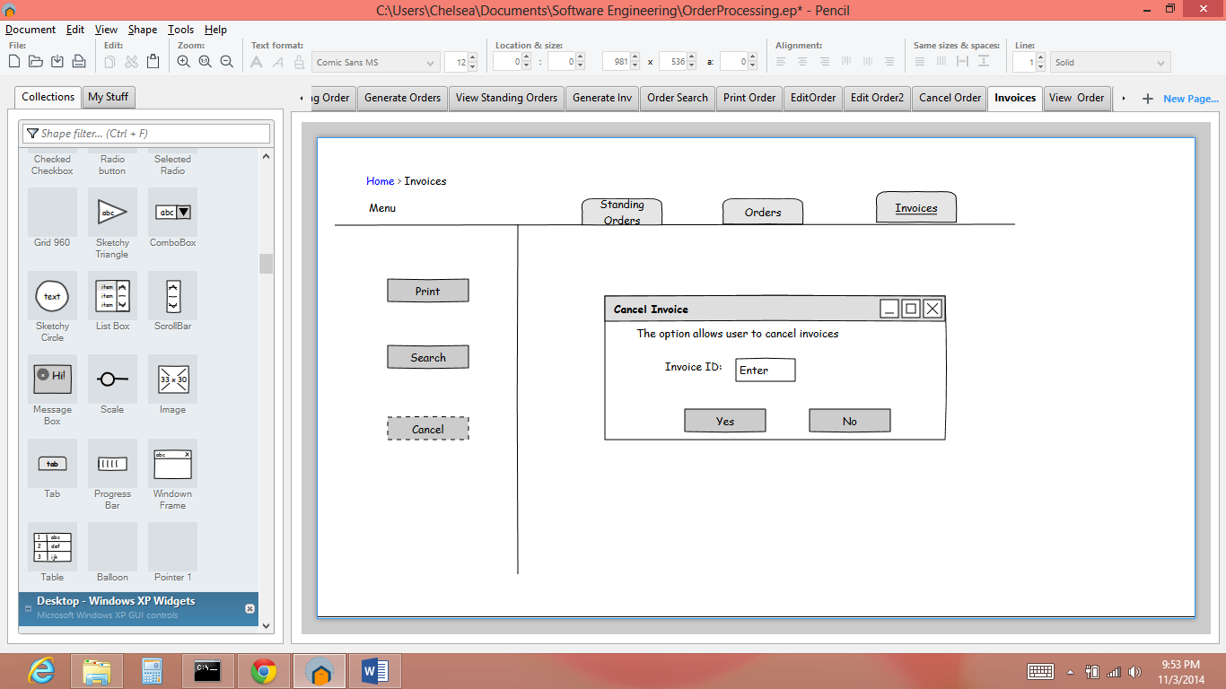

Fig 16: Displays the Cancel Invoices window when the user selects the Cancel Option.

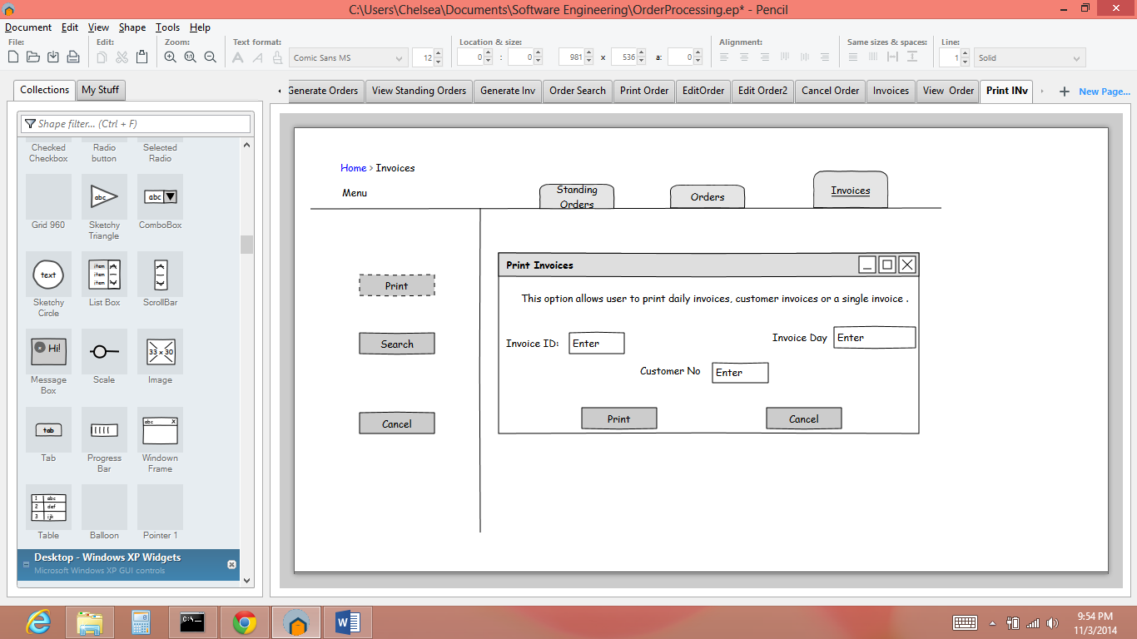

Fig 17: Displays the print Invoices window which allows the user to print one or more invoices.

Sequence Diagrams













Orders











Resource Tables

**Standing Order Resource Table**

|  |  |  |  |
| --- | --- | --- | --- |
| Action | Input Parameters | Output | Description |
| GET | CustNo/Token | {StdOrder#, Date Created,Status,Day} | Bring up list of all of a customer’s standing orders |
| StdOrderId/ Token | {StdOrder#, Date Created,Status,Day, ItemNo, Item, Quantity,ItemStatus, Price} | Returns standing order |
| StdOrderID/itemNo/token | {ItemNo, Item, Quantity, Status, Price} | Returns a standing order item. |
| PUT | CustNo/Data (Day/Frequency/Items/Quantity)/Token | Json String | Creates a standing order for a customer |
| POST | DeleteItem/token/itemNo  Edit/token/StdOrderId | boolean json object or string | This option deletes all instances of an item from all standing orders.  Modifies a standing order based on customer input |
| DELETE | StdOrderId/token | Boolean Json Object | Deletes a standing order |

**Order Resource Table**

|  |  |  |  |
| --- | --- | --- | --- |
| Action | Input Parameters | Output | Description |
| GET | CustomerNo/Token | {OrderNo, StdOrderNo,Date Created,Status,Day} | Bring up list of all of a customer’s orders |
| Day / Token | {OrderNo, StdOrderNo ,Day} | Returns a list of all the orders for that day |
| OrderId/ Token | {OrderNo, StdOrderNo,Day} | Returns an order |
| OrderID/itemNo/token | {ItemNo, Item, Quantity, Status, Price} | Returns an order item. |
| POST | Delete/token/OrderID | boolean json object or string | Modifies an order based on customer input |
| DELETE | OrderID/token | Boolean Json Object | Deletes an order |